## 

## LAB CYCLE II

Anunadh Rajesh

S2MCA

20MCA015

# Q. SET1

## Create the following tables and execute the queries given below SAILORS

|  |  |  |  |
| --- | --- | --- | --- |
| **sid** | **sname** | **rating** | **age** |
| 22 | Dustin | 7 | 45 |
| 29 | Brutas | 1 | 33 |
| 31 | Lubber | 8 | 55 |
| 32 | Andy | 8 | 25 |
| 58 | Rusty | 10 | 35 |
| 64 | Horatio | 7 | 35 |
| 71 | Zorba | 10 | 16 |
| 74 | Horatio | 9 | 35 |
| 85 | Art | 3 | 26 |
| 95 | Bob | 3 | 64 |

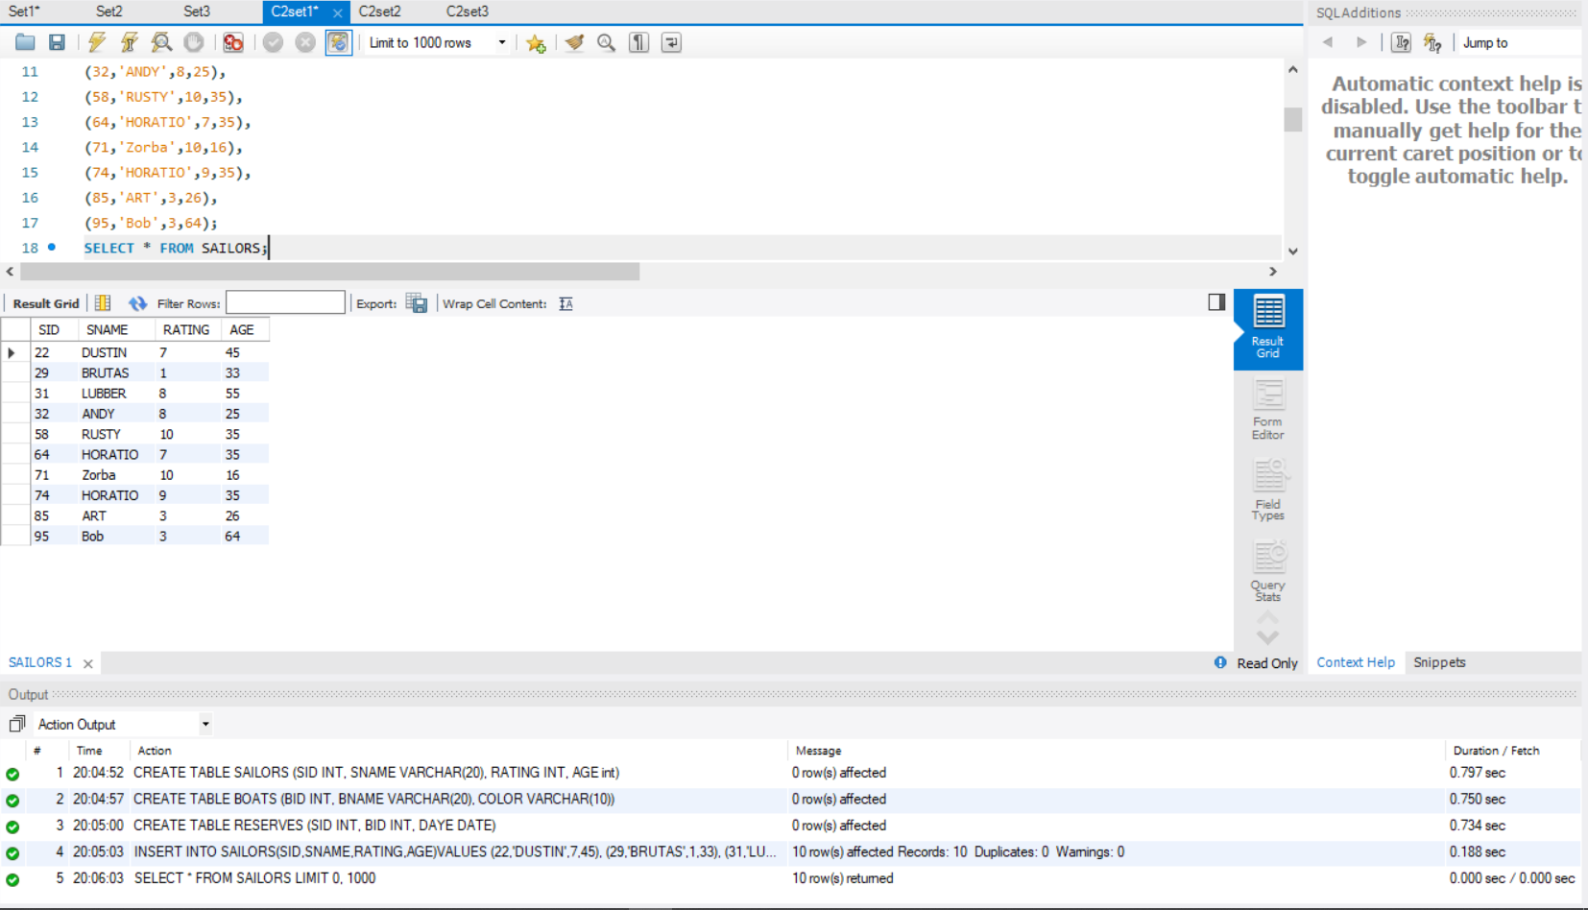

**BOATS**

|  |  |  |
| --- | --- | --- |
| **Bid** | **bname** | **color** |
| 101 | Interlake | Blue |
| 102 | Interlake | Red |
| 103 | Clipper | Green |
| 104 | Marine | Red |

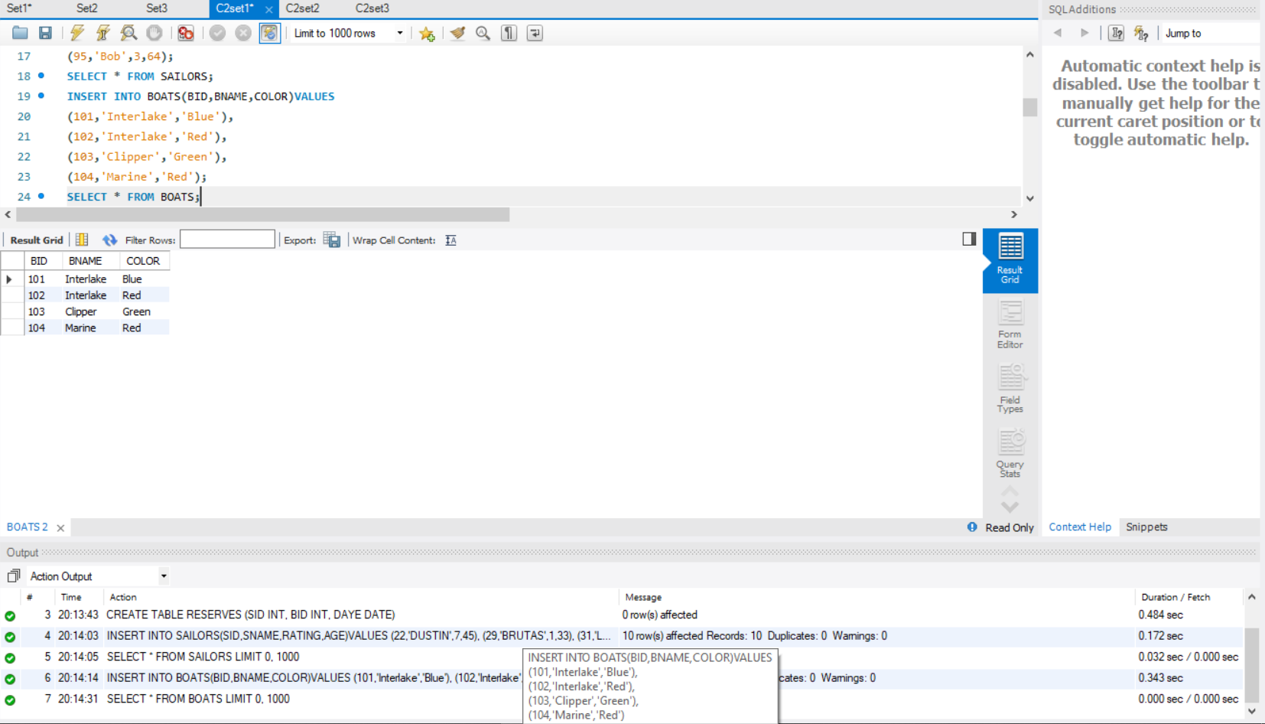

**RESERVES**

|  |  |  |
| --- | --- | --- |
| **sid** | **bid** | **day** |
| 22 | 101 | 10/10/98 |
| 22 | 102 | 10/10/98 |
| 22 | 103 | 10/8/98 |

|  |  |  |
| --- | --- | --- |
| 22 | 104 | 10/7/98 |
| 31 | 102 | 11/10/98 |
| 31 | 103 | 11/6/98 |
| 31 | 104 | 11/12/98 |
| 64 | 101 | 9/5/98 |
| 64 | 102 | 9/8/98 |
| 74 | 103 | 9/8/98 |

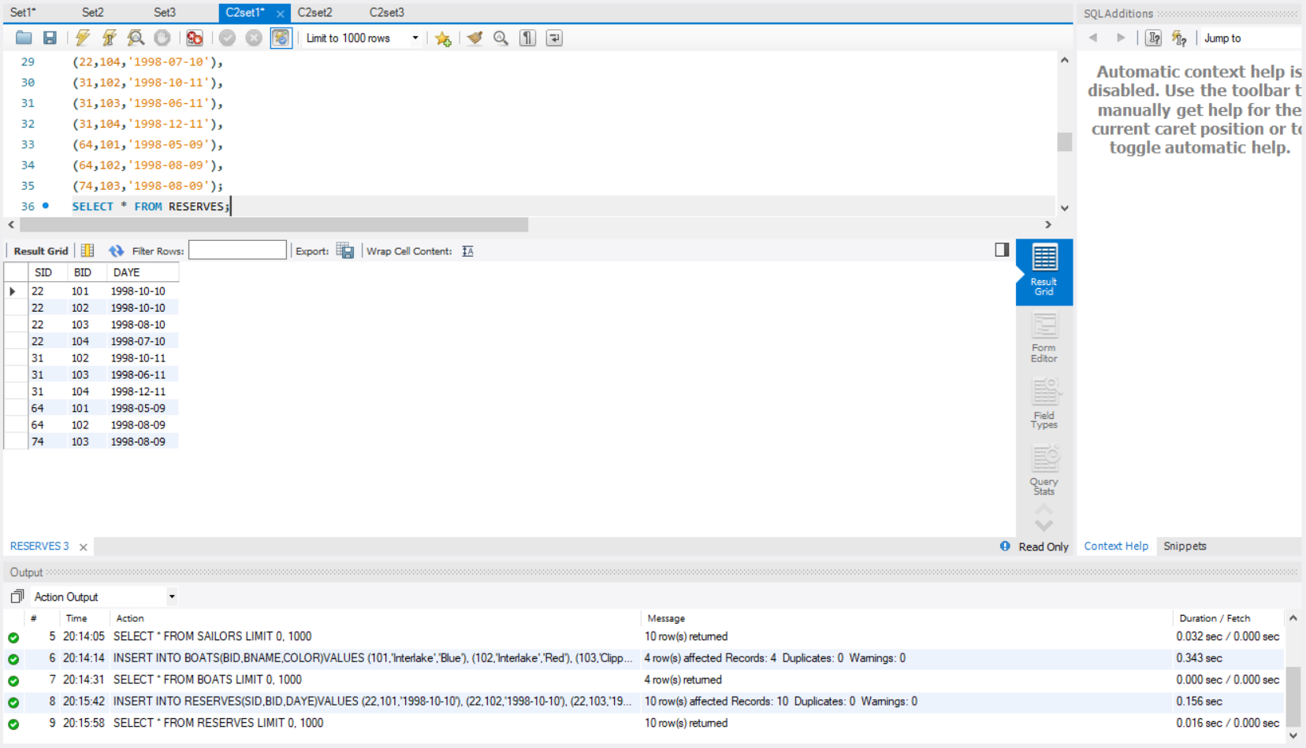

1. **Find the names and ages of all sailors**

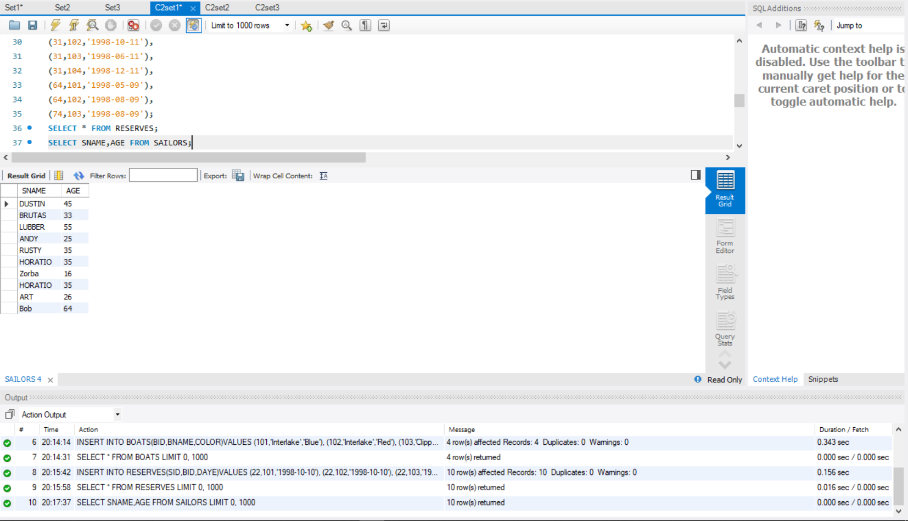

1. **Find all information of sailors who have reserved boat number 101.**

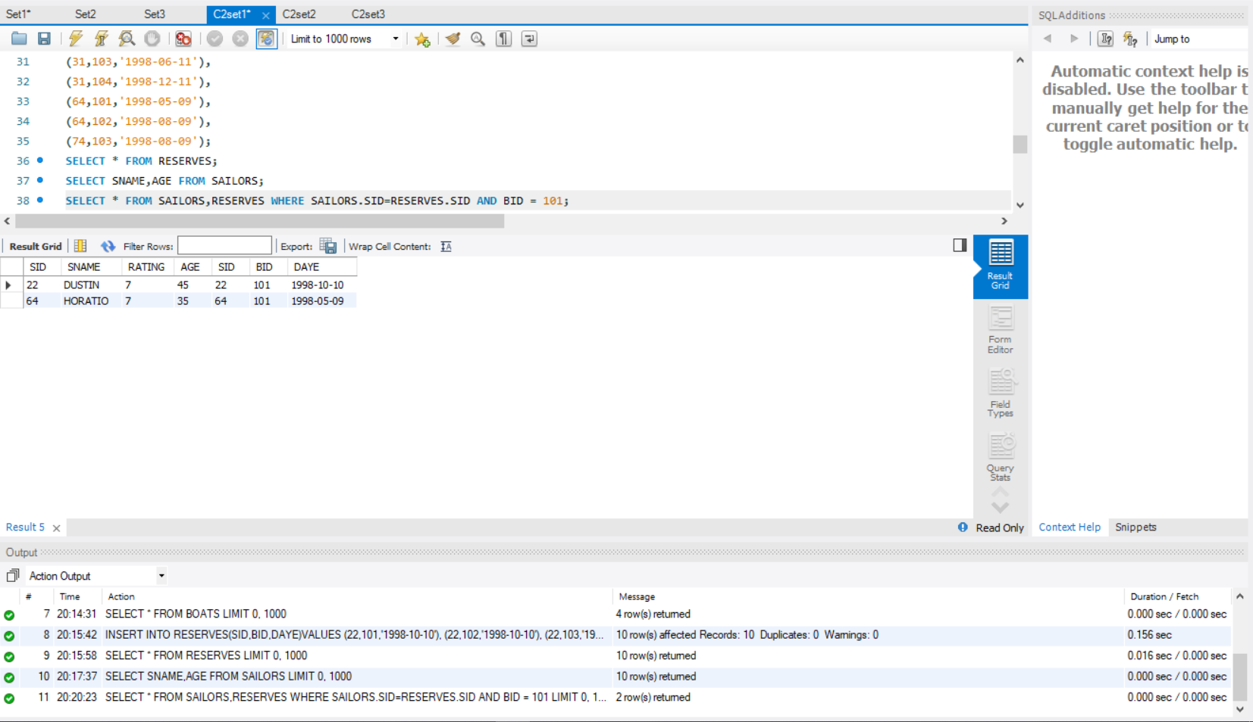

1. **Find all sailors with rating above 7**

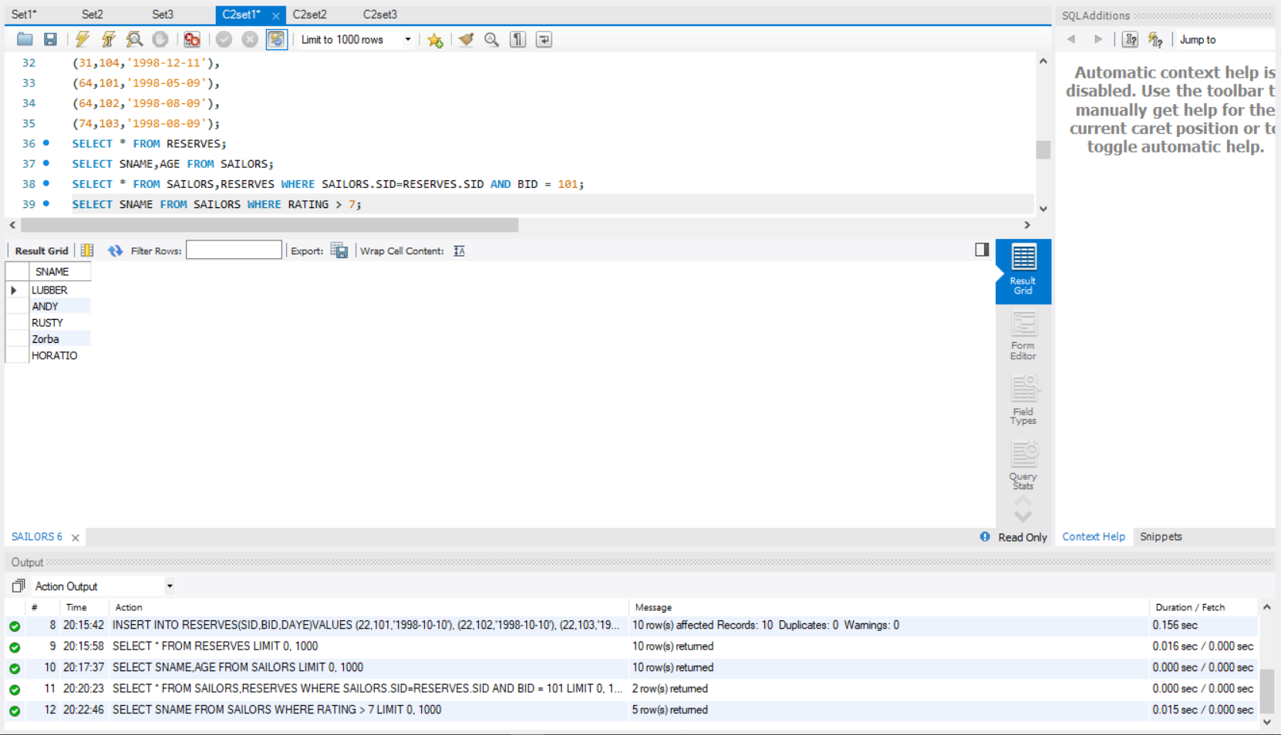

1. **Find the names of sailors who have reserved boat no 103**

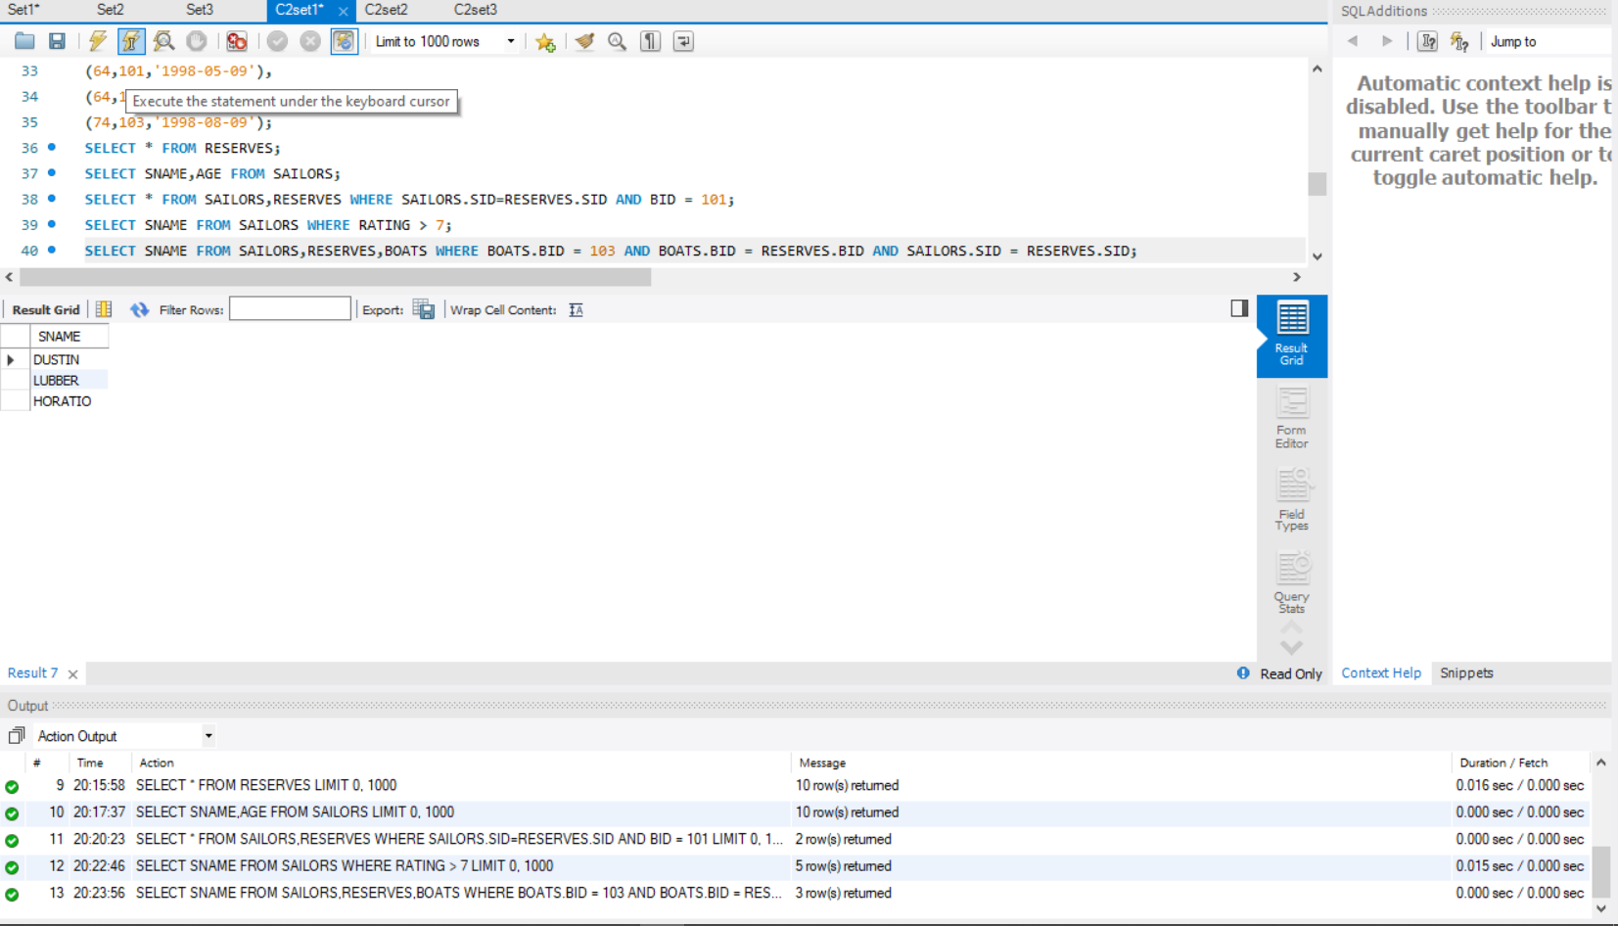

1. **Find the names of sailors who have reserved a red boat, and list in the order of age.**

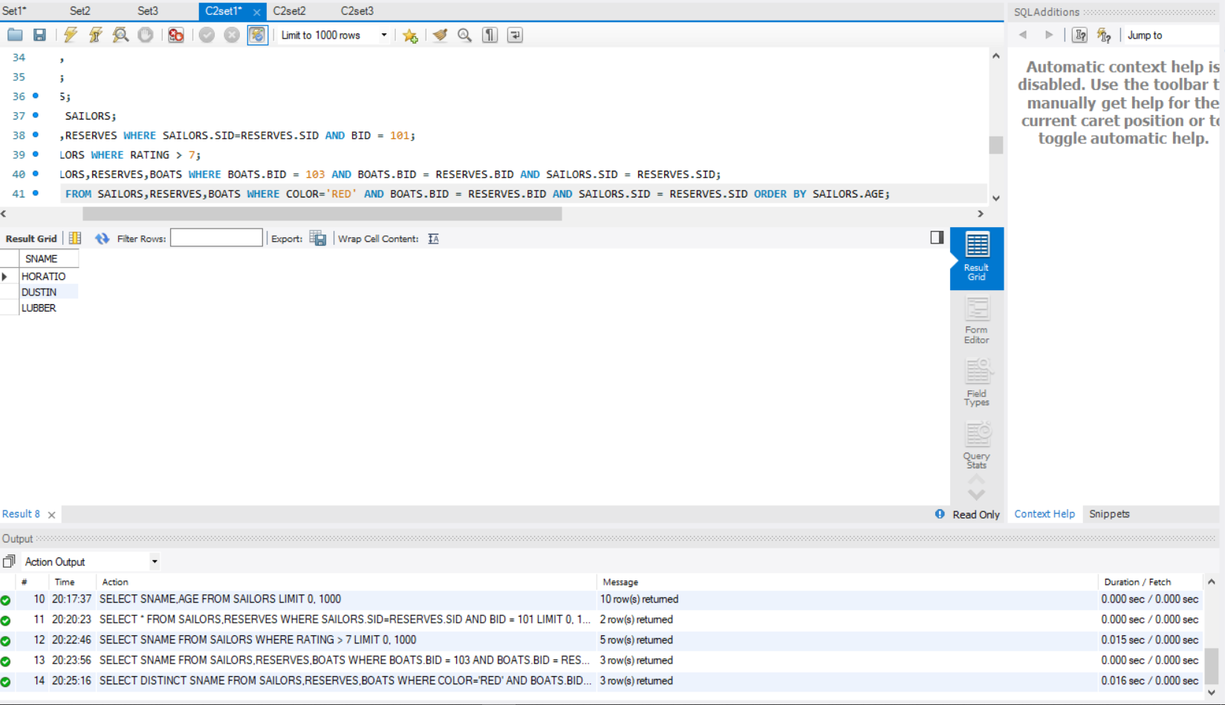

1. **Find the names of sailors who have reserved either a red or green boat**

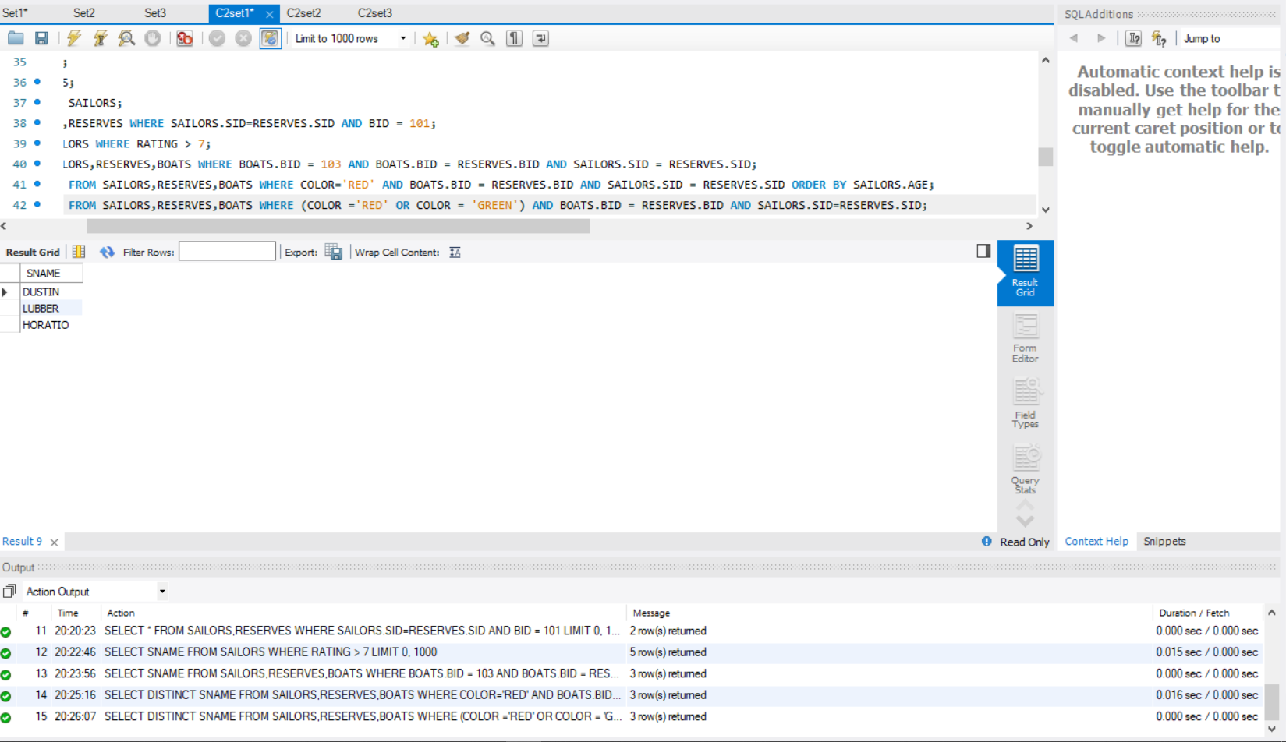

1. **Find the colors of boats reserved by “Lubber”.**

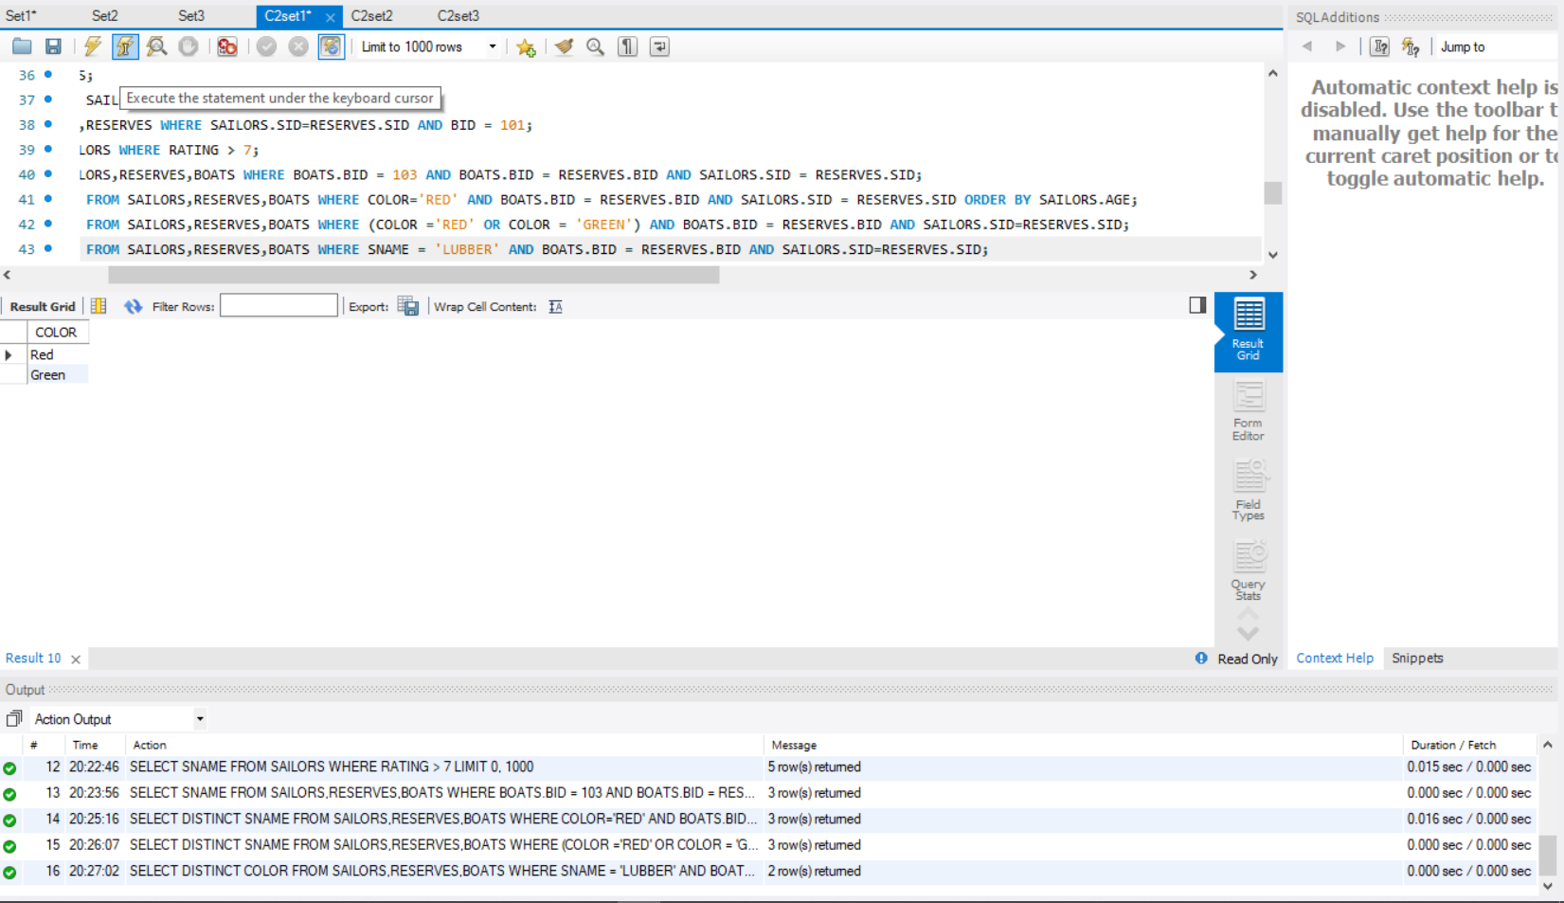

1. **Find the names of sailors who have reserved both red and green boats**

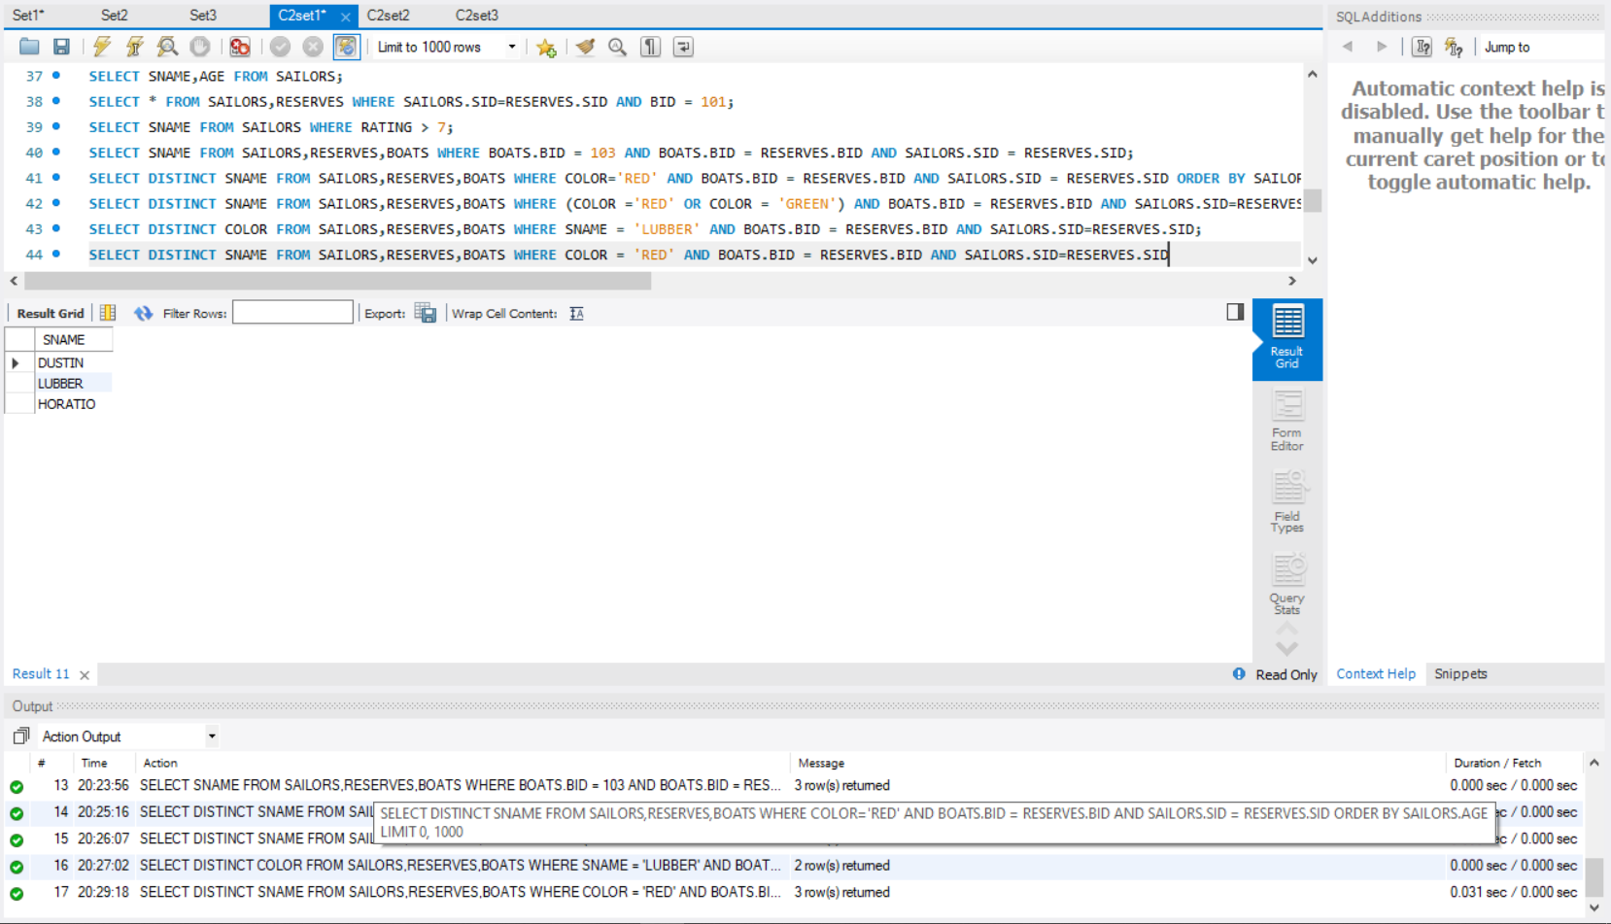

1. **Find the names of sailors who have reserved at least one boat**

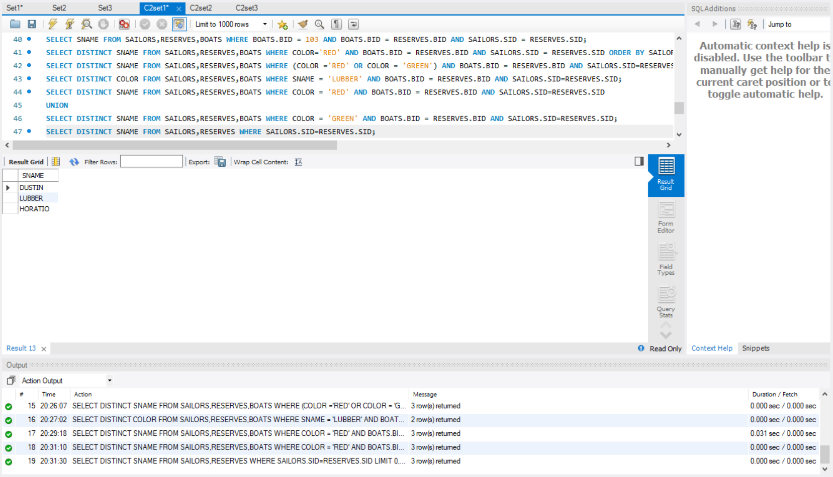

1. **Find the ids and names of sailors who have reserved two different boats on the same day.**

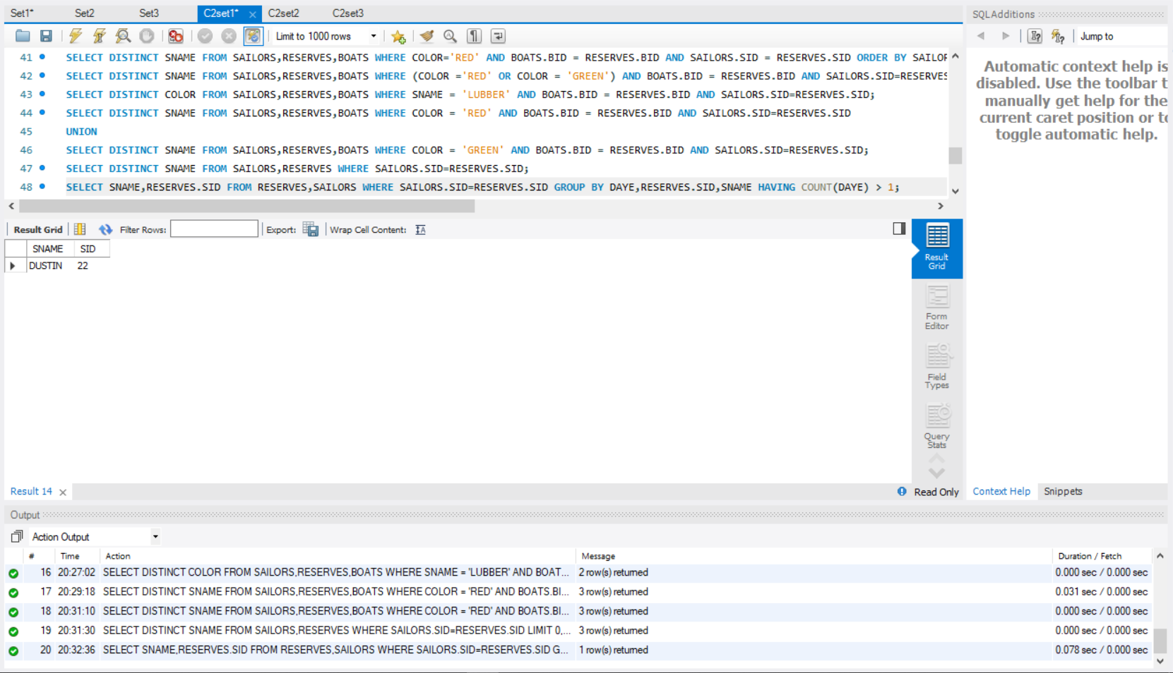

1. **Find the name and the age of the youngest sailor.**

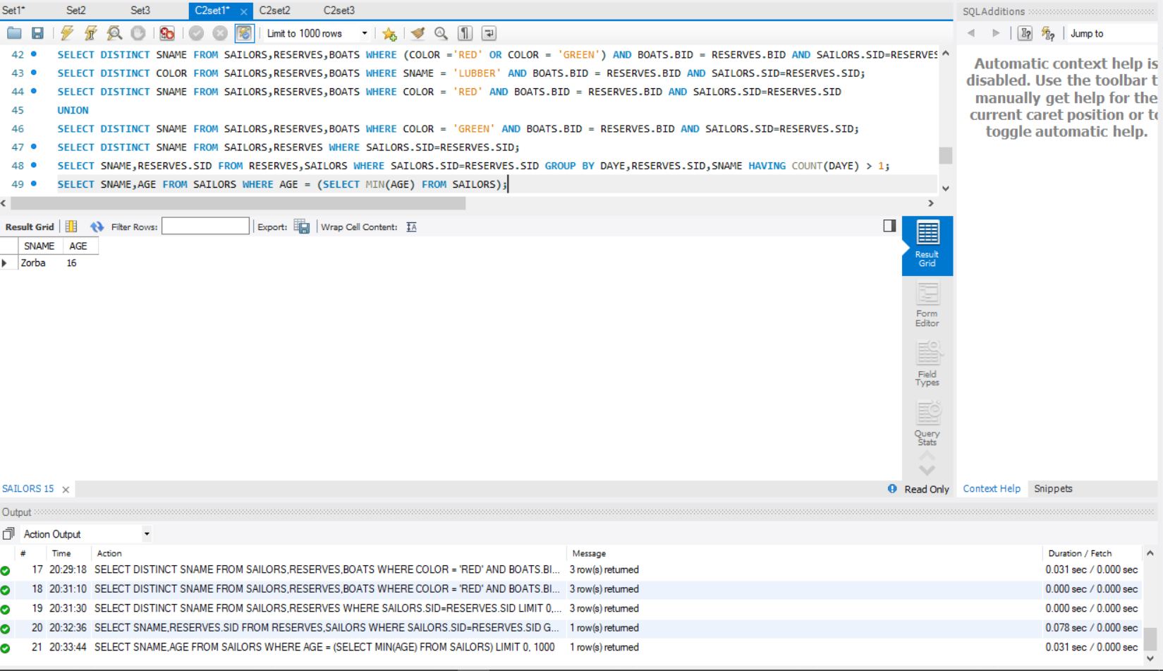

1. **Find the names and ratings of sailor whose rating is better than some sailor called Horatio.**

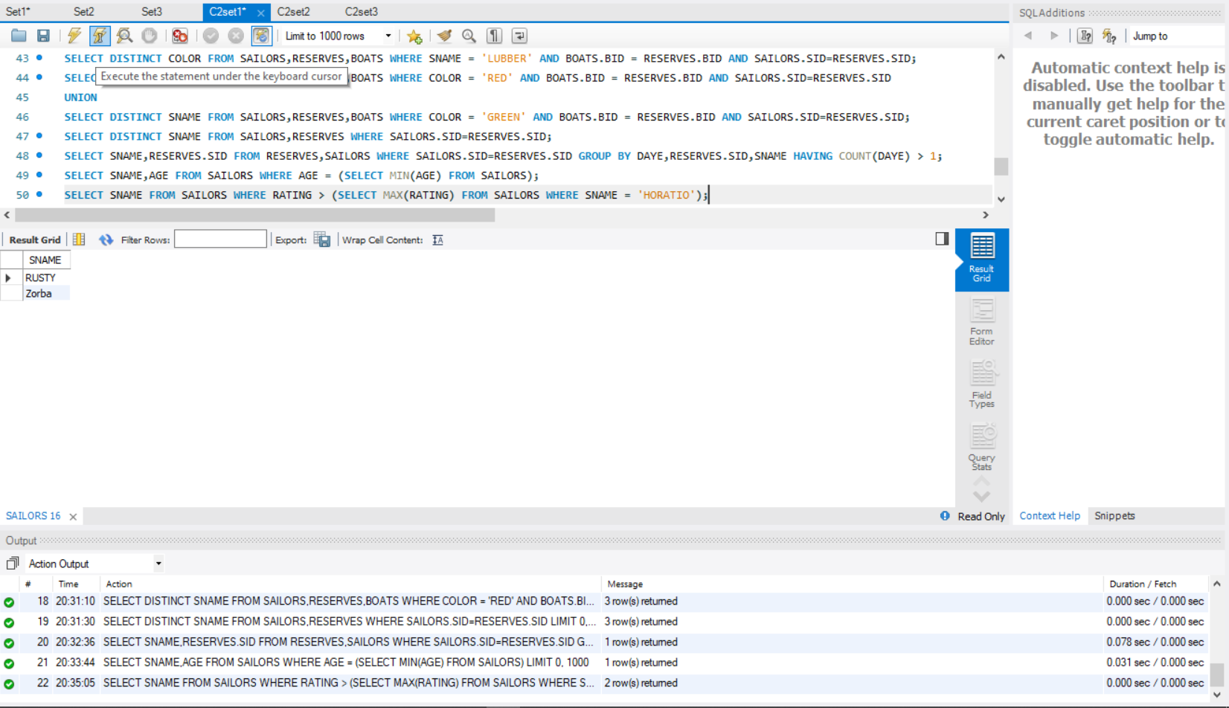

**13.Find the names of sailors who have reserved all boats.**

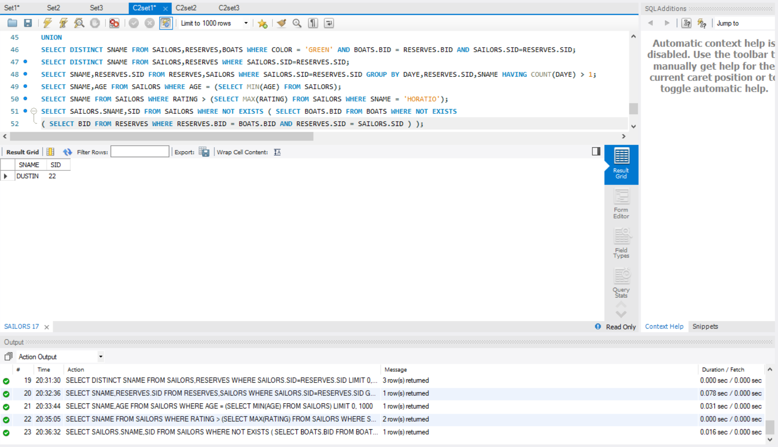

14.**Count the number of different sailor names.**

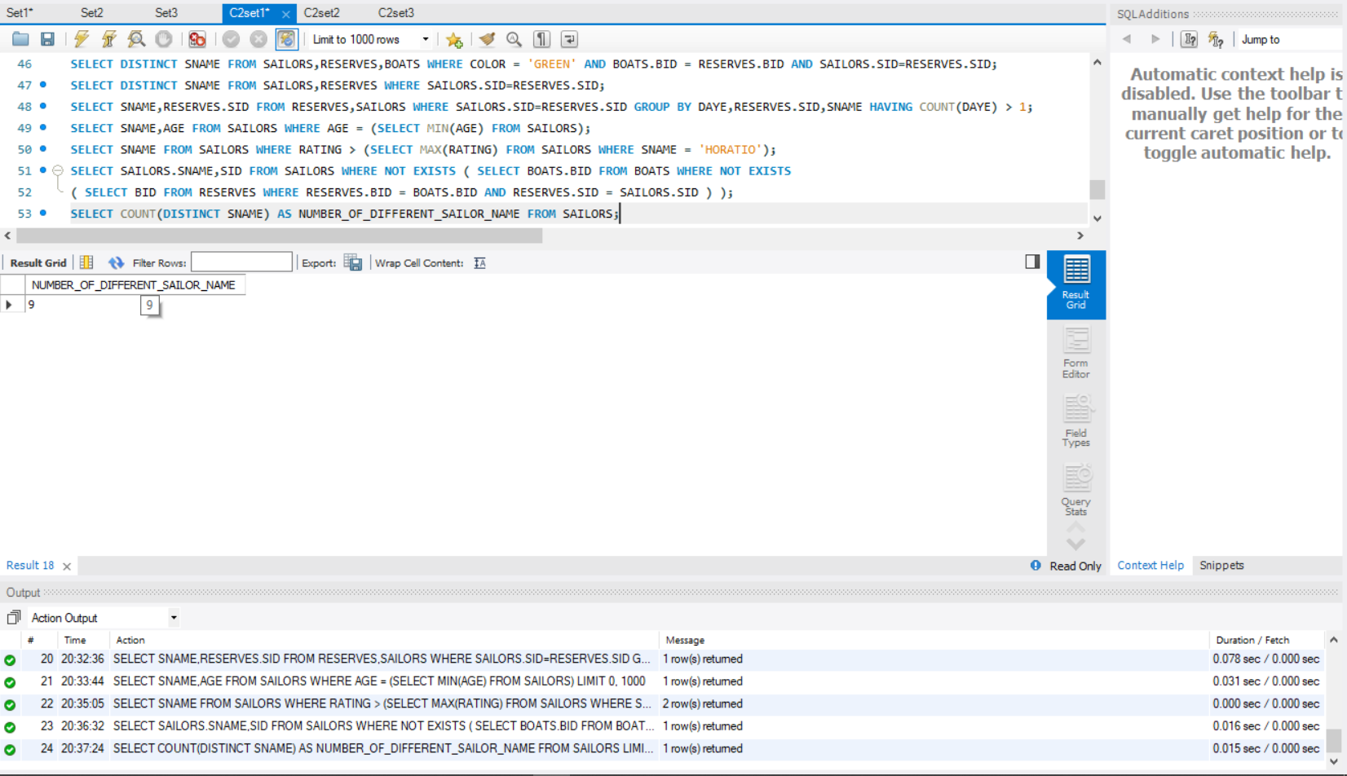

1. **Calculate the average age of all sailors.**

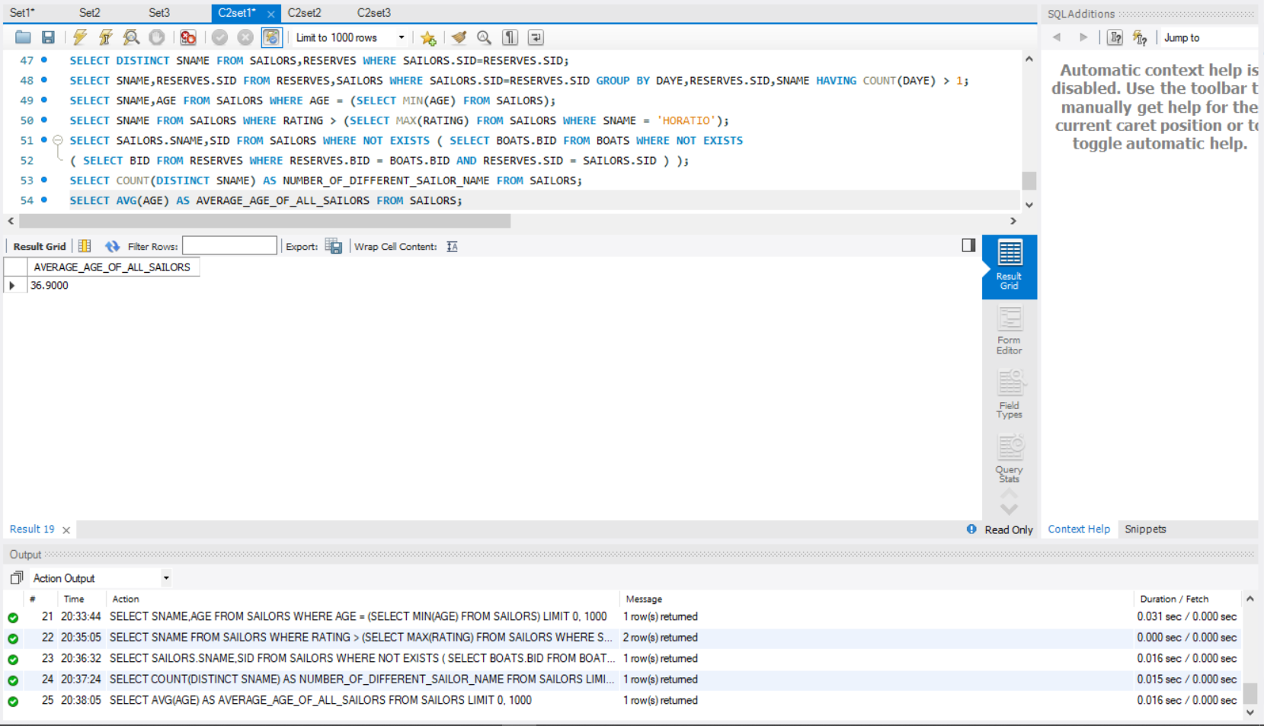

1. **Find the average age of sailors for each rating level.**

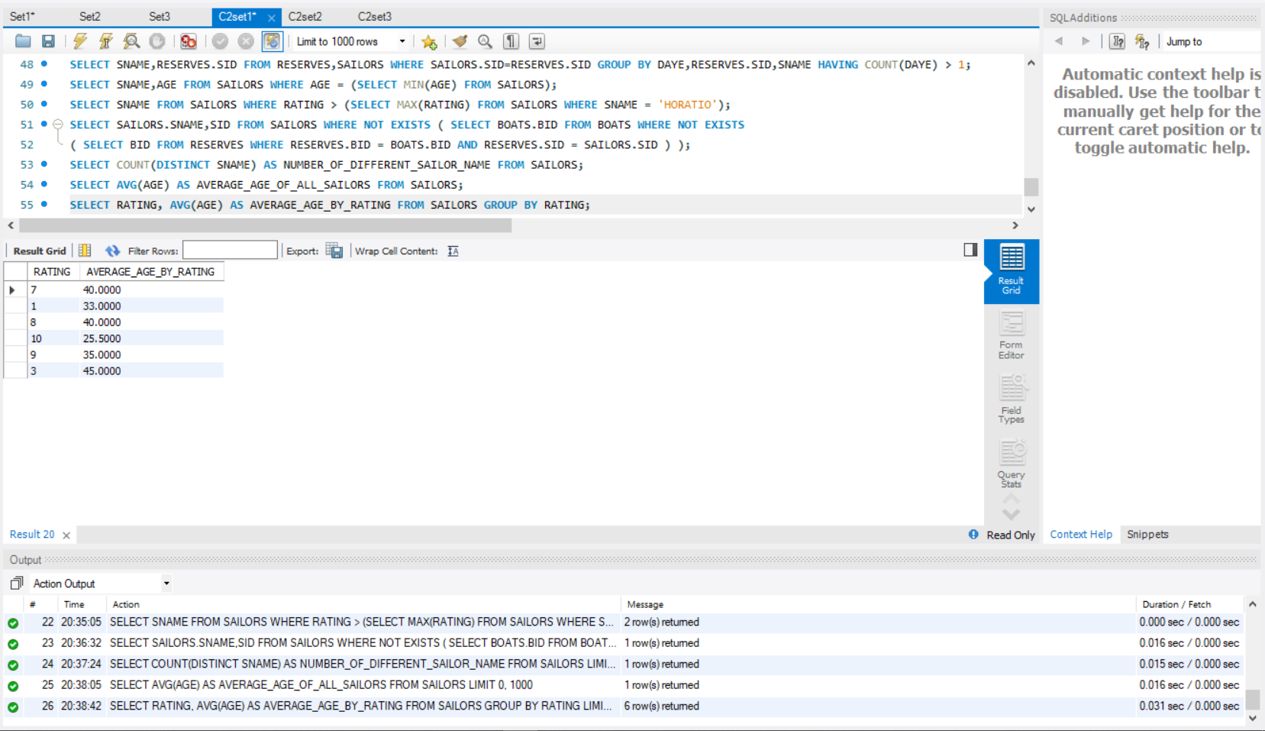

1. **Find the average age of sailors for each rating level that has at least two sailors.**

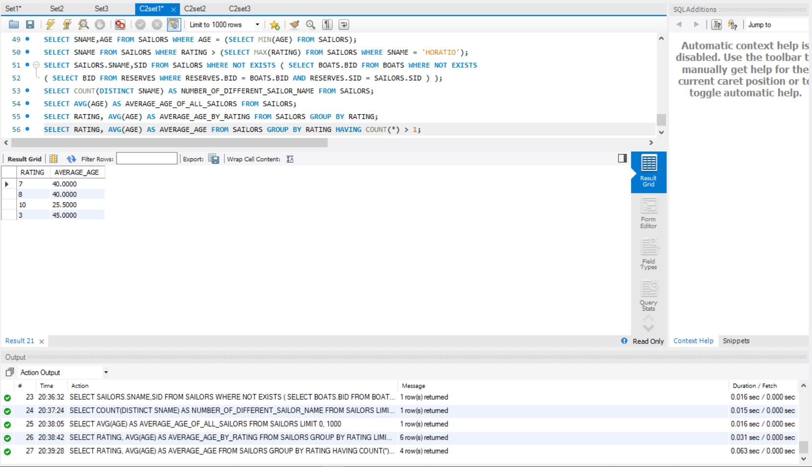

# Q .SET 2

1. **Create the table STUDENT_INFO with Columns: Sid, Stud_name & stude_score.**
   * **Insert values into STUDENT_INFO with the following constraints:Sid should be unique, Stud name NOT NULL and stude_score DEFAULT value of 20.**
   * **Set Sid as primary key.**
   * **Update stude_score by adding a value of 5 to stude_score in the table STUDENT_INFO for the rows satisfying the condition of stude_score >150 (Using CASE)**

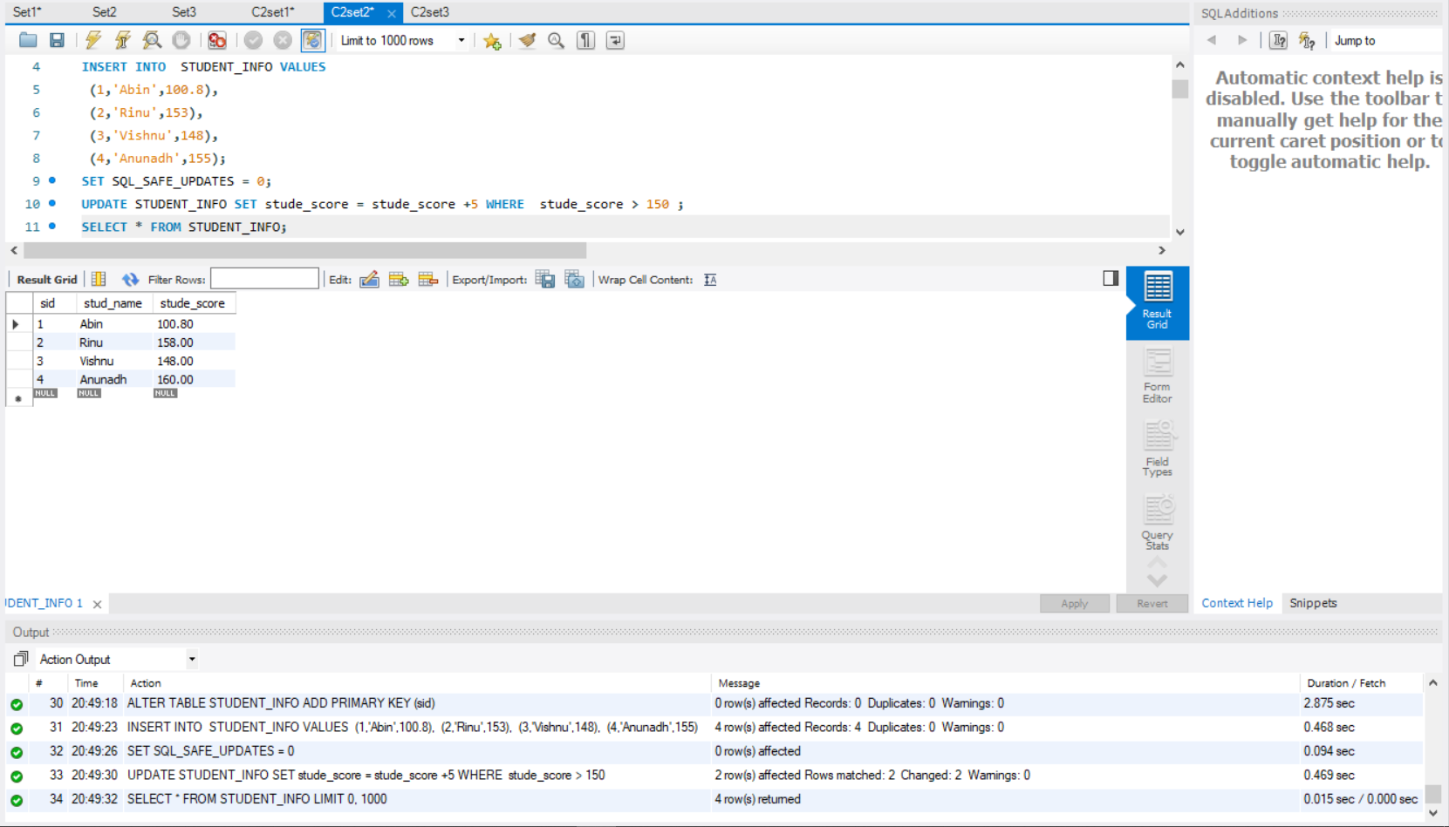

1. **Create the tables worker and bonus with the following fields. The primary key of Worker table is Worker_ID. Set Worker_id as foreign key of bonus on update and delete cascade constraints. Each constraint should be given a name**

|  |  |  |  |  |  |
| --- | --- | --- | --- | --- | --- |
| **WORKER_ID** | **FIRST_NAME** | **LAST_NAME** | **SALARY** | **JOINING_DATE** | **DEPARTMENT** |
| 1 | Monika | Arora | 100000 | 2014-02-20 | HR |
| 2 | Niharika | Verma | 80000 | 2014-06-11 | Admin |
| 3 | Vishal | Singhal | 300000 | 2014-02-20 | HR |
| 4 | Amitabh | Singh | 500000 | 2014-02-20 | Admin |
| 5 | Vivek | Bhati | 500000 | 2014-06-11 | Admin |
| 6 | Vipul | Diwan | 200000 | 2014-06-11 | Account |
| 7 | Satish | Kumar | 75000 | 2014-01-20 | Account |
| 8 | Geetika | Chauhan | 90000 | 2014-04-11 | Admin |
|  |  |  |  |  |  |

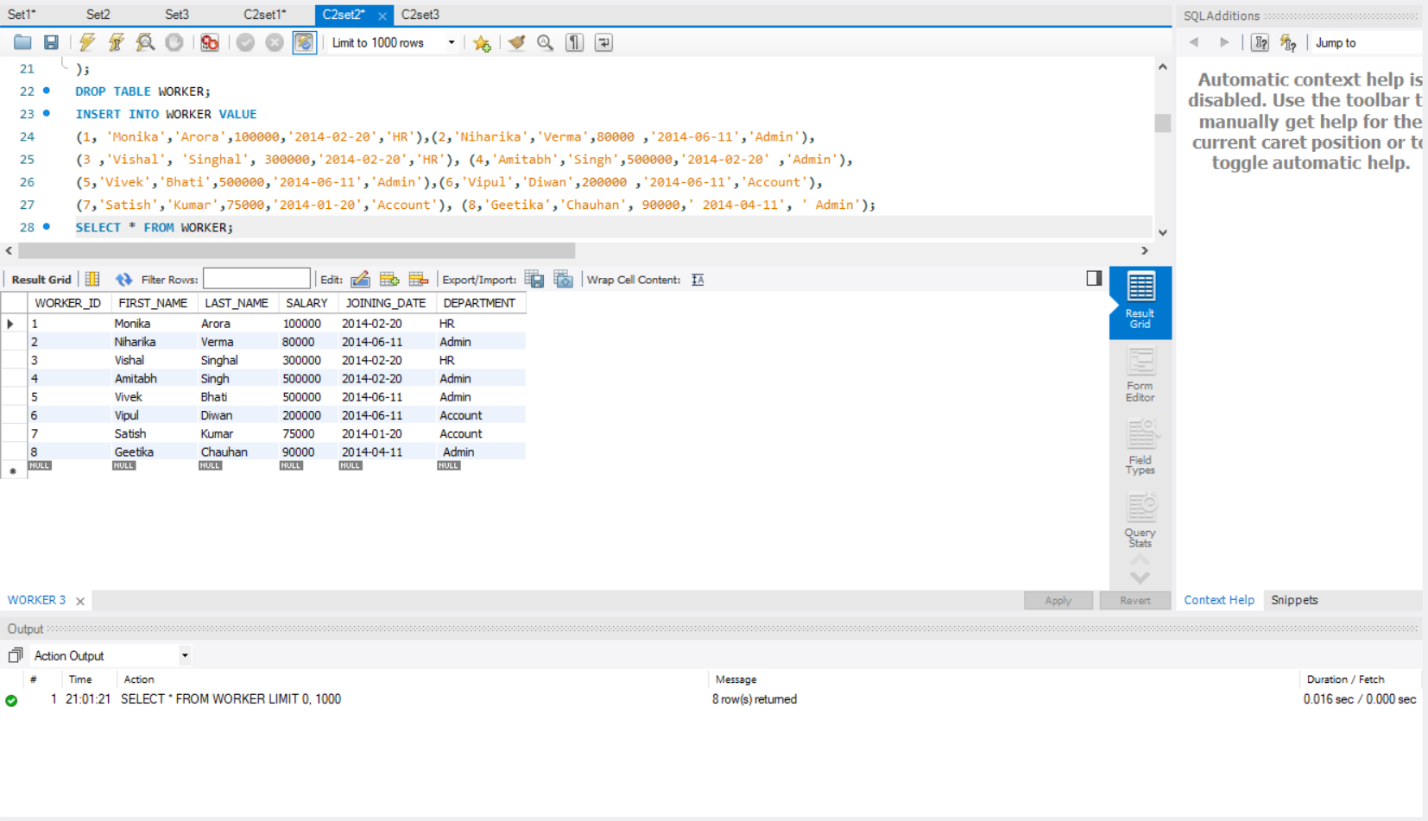

1. **Sample Table – Bonus**

|  |  |  |
| --- | --- | --- |
| **WORKER_ID** | **BONUS_DATE** | **BONUS_AMOUNT** |
| 1 | 2016-02-20 | 5000 |
| 2 | 2016-06-11 | 3000 |
| 3 | 2016-02-20 | 4000 |
| 1 | 2016-02-20 | 4500 |
| 2 | 2016-06-11 | 3500 |

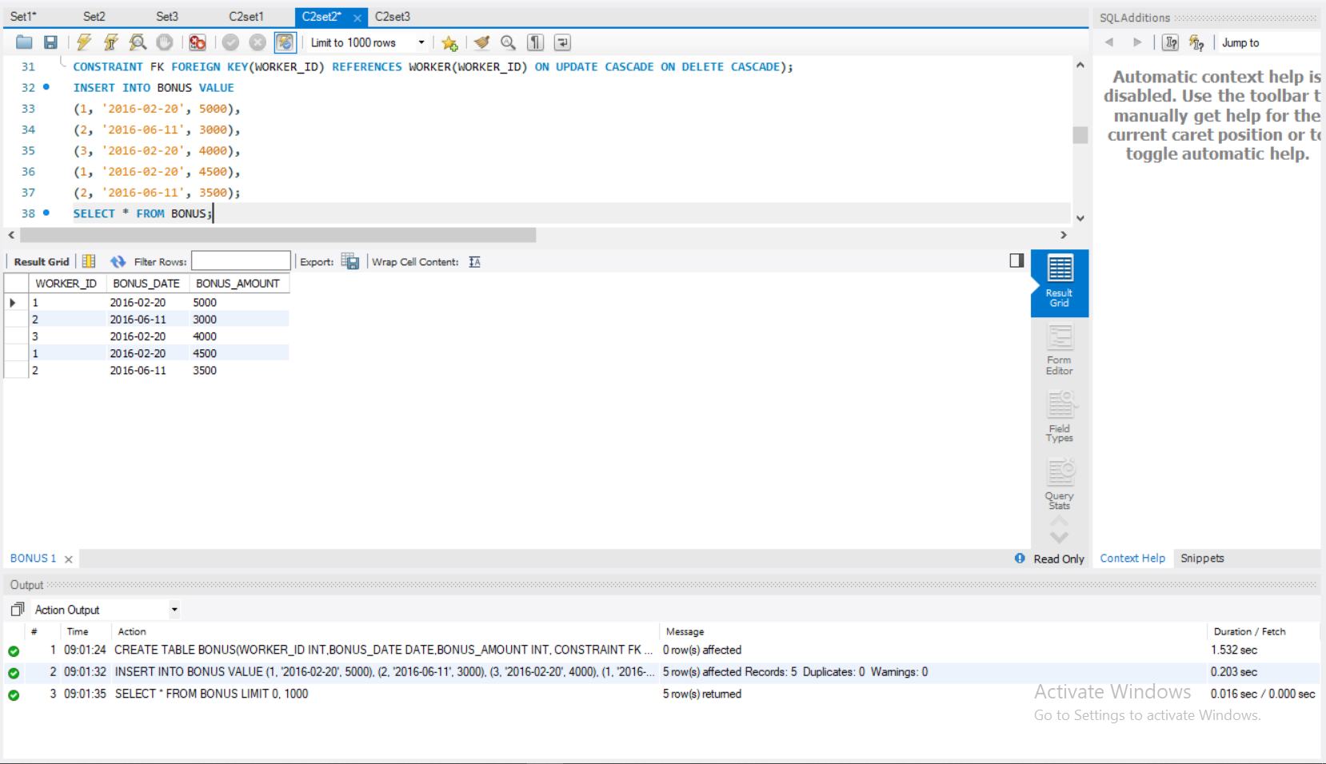

1. **Write An SQL Query To Fetch “FIRST_NAME” From Worker Table Using The Alias Name As <WORKER_NAME>.**

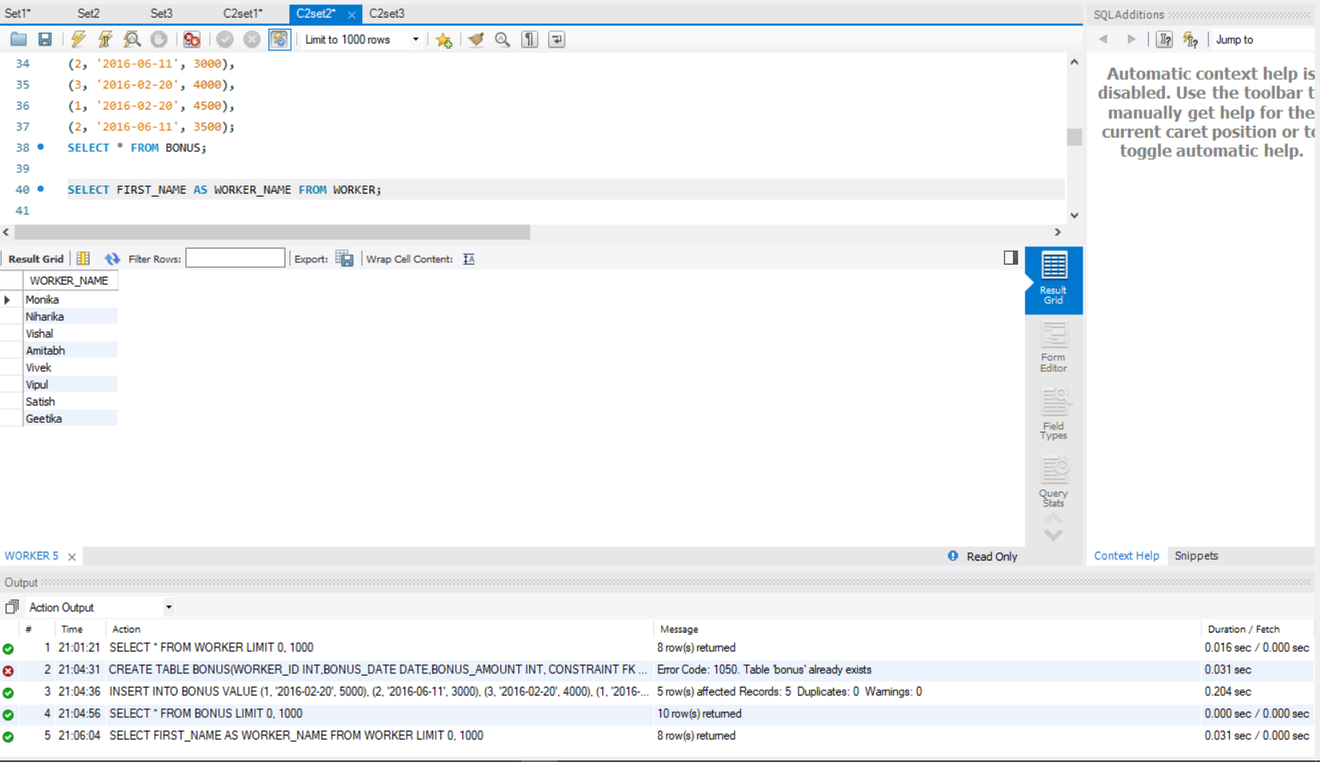

1. **Write An SQL Query To Print All Worker Details From The Worker Table Order By FIRST_NAME Ascending**

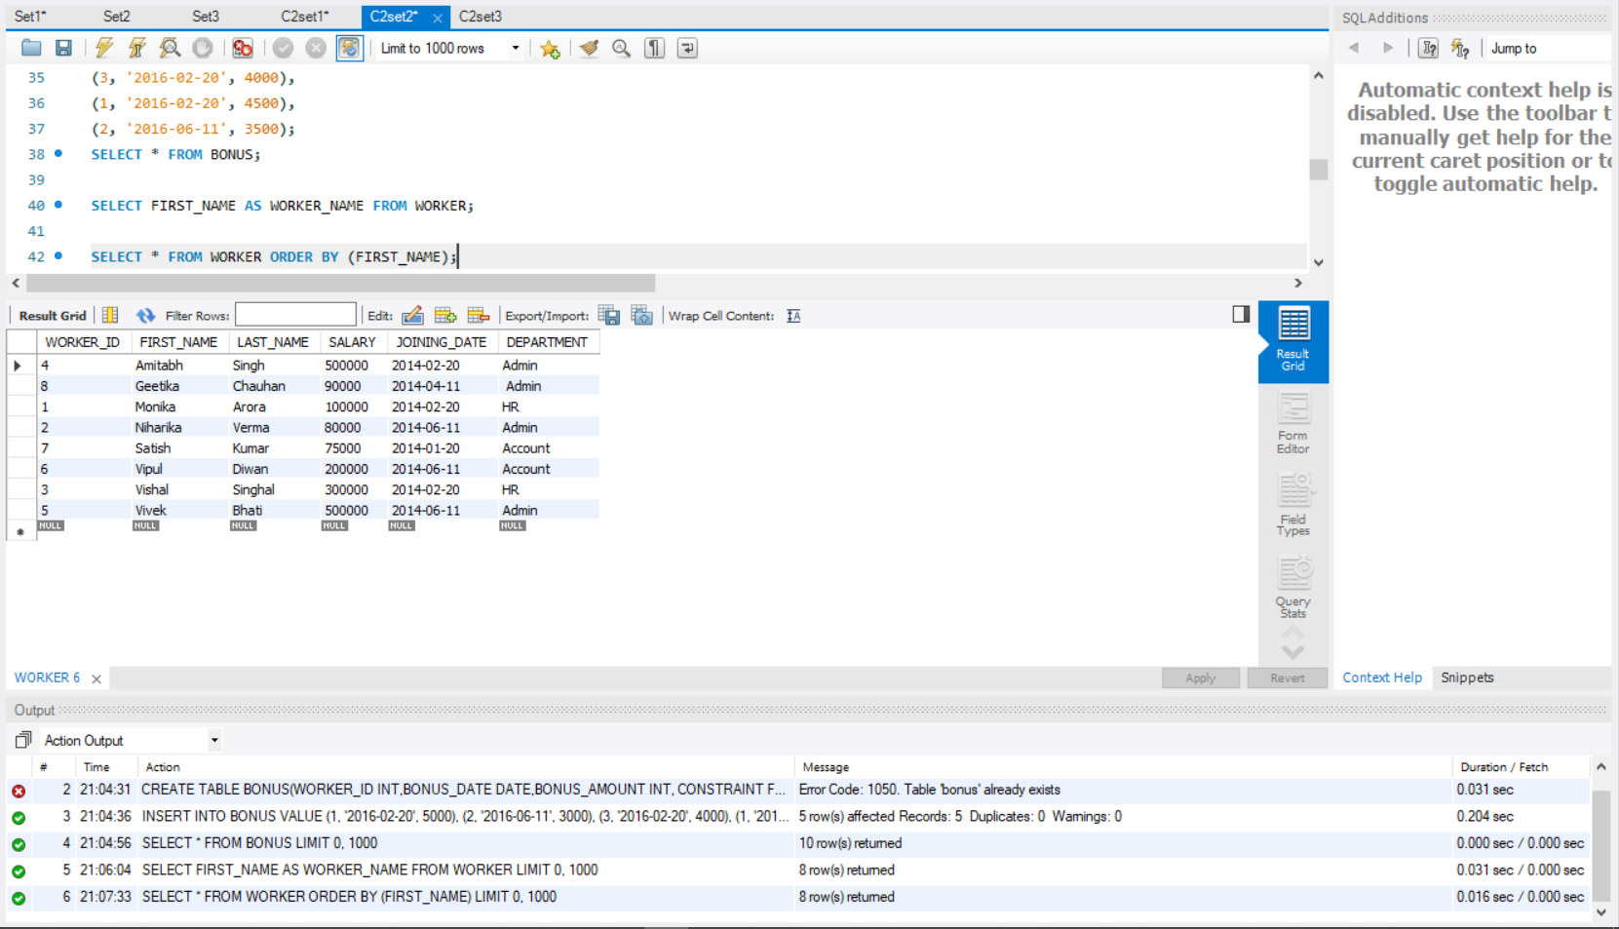

1. **Write An SQL Query To Print Details Of Workers Excluding First Names, “Vipul” And “Satish” From Worker Table.**

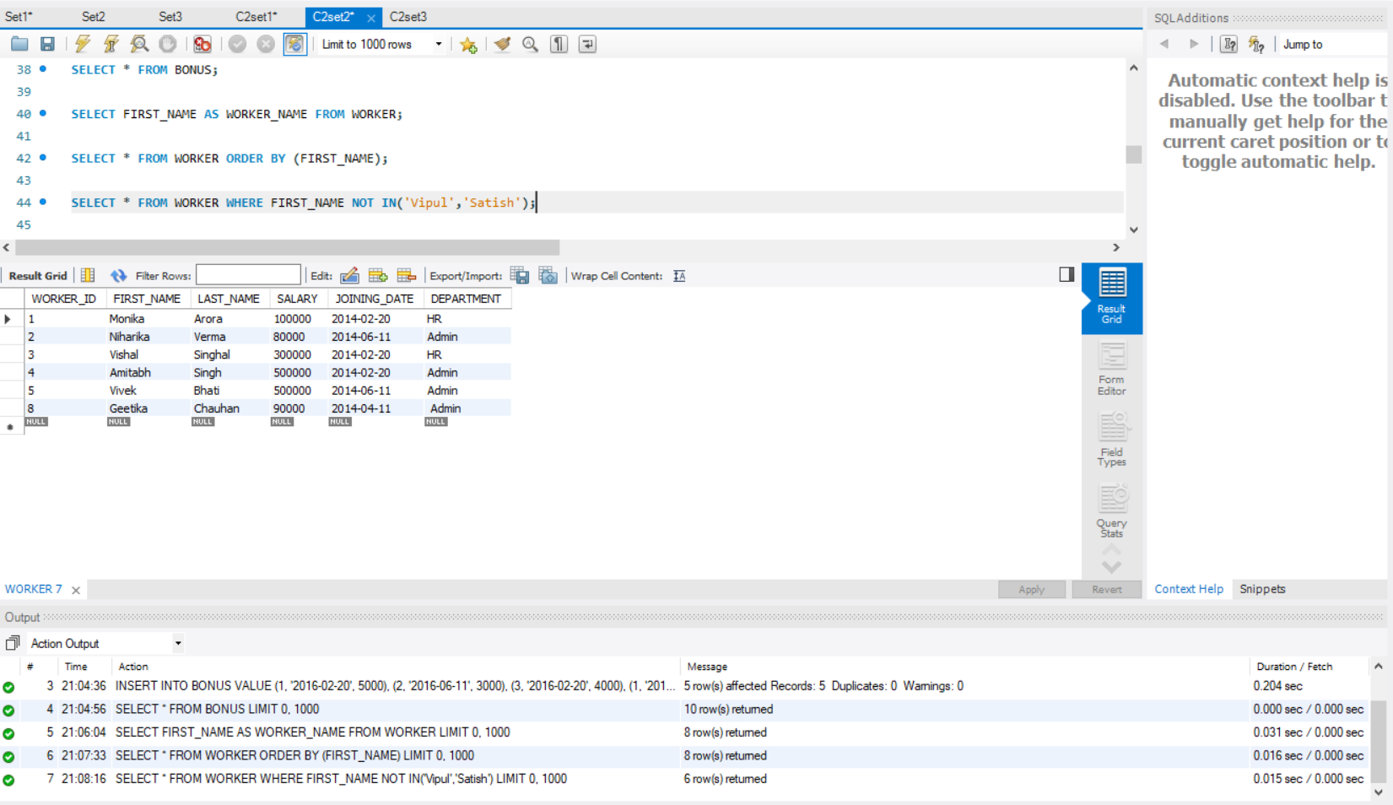

1. **Write An SQL Query To Print Details Of Workers With DEPARTMENT Name As “Admin”.**

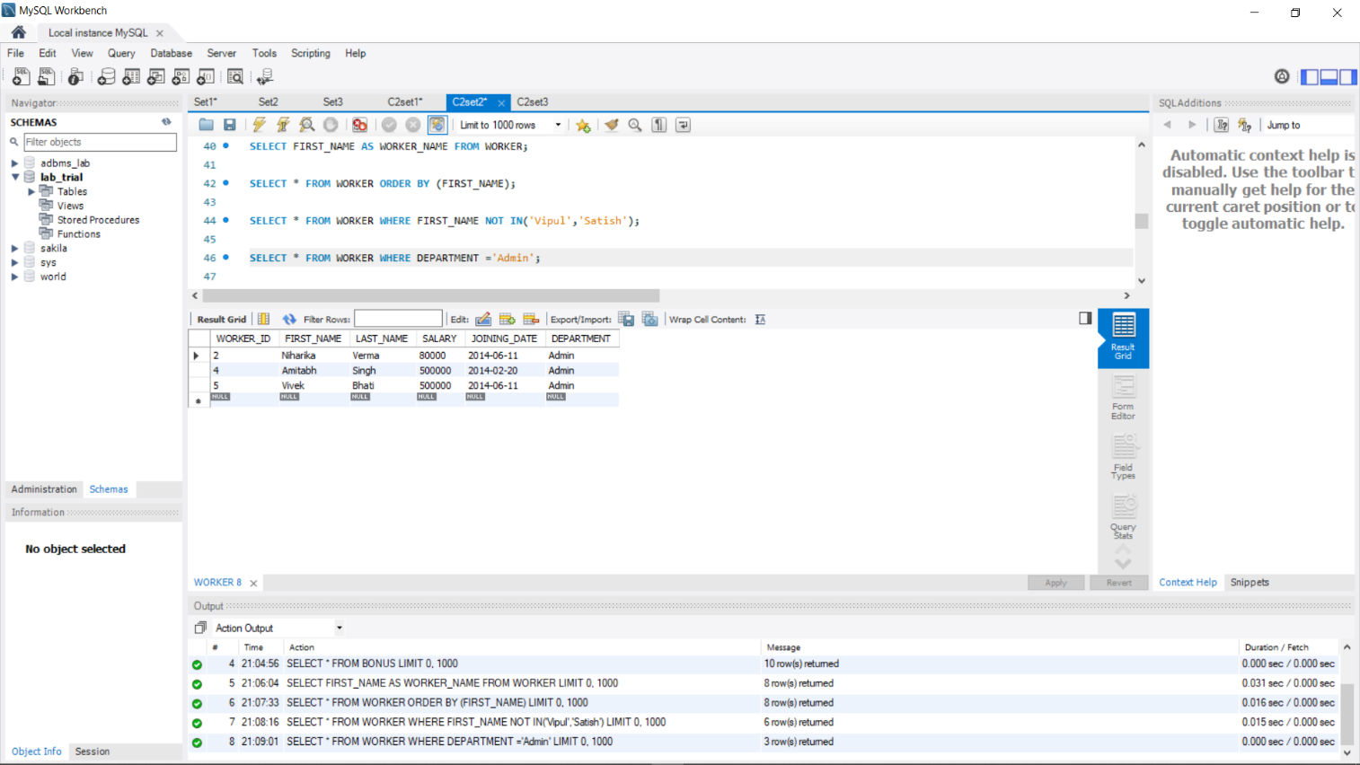

1. **Write An SQL Query To Print Details Of The Workers Whose SALARY Lies Between 100000 And 500000**

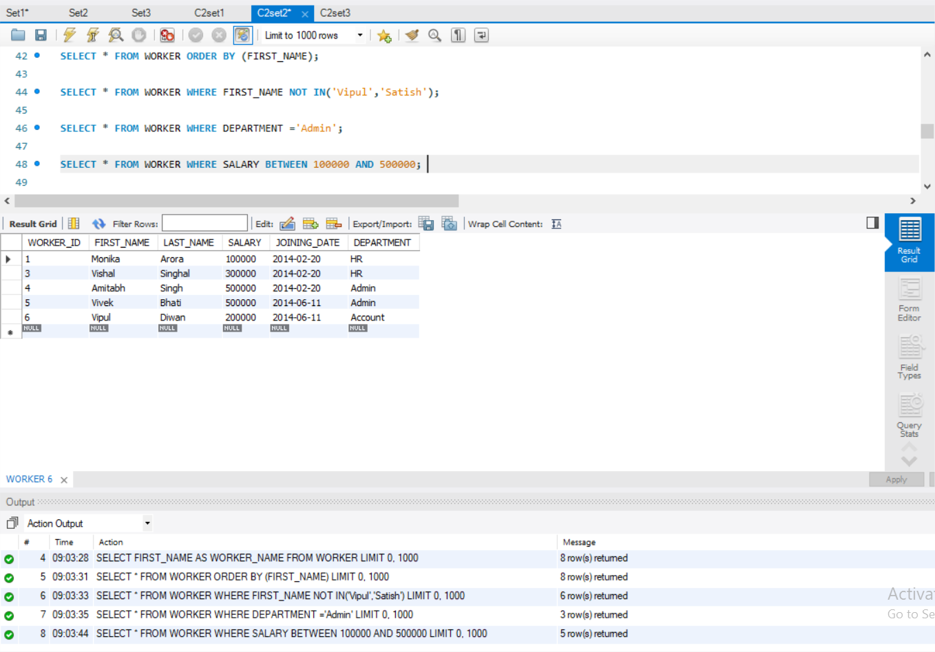

1. **Write An SQL Query To Fetch “FIRST_NAME” From Worker Table In Upper Case. (upper())**

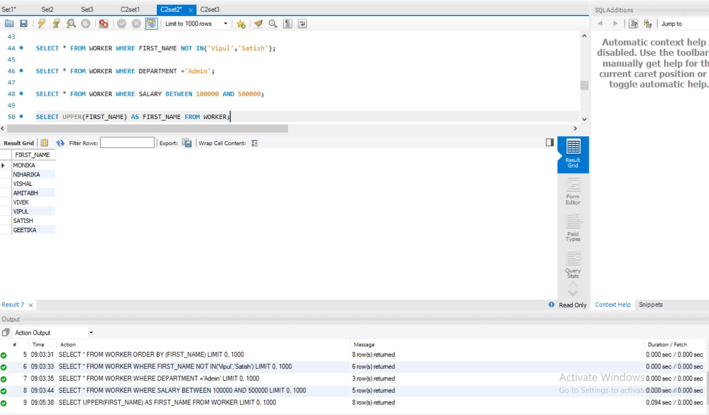

1. **Write An SQL Query To Fetch Unique Values Of DEPARTMENT From Worker Table.**

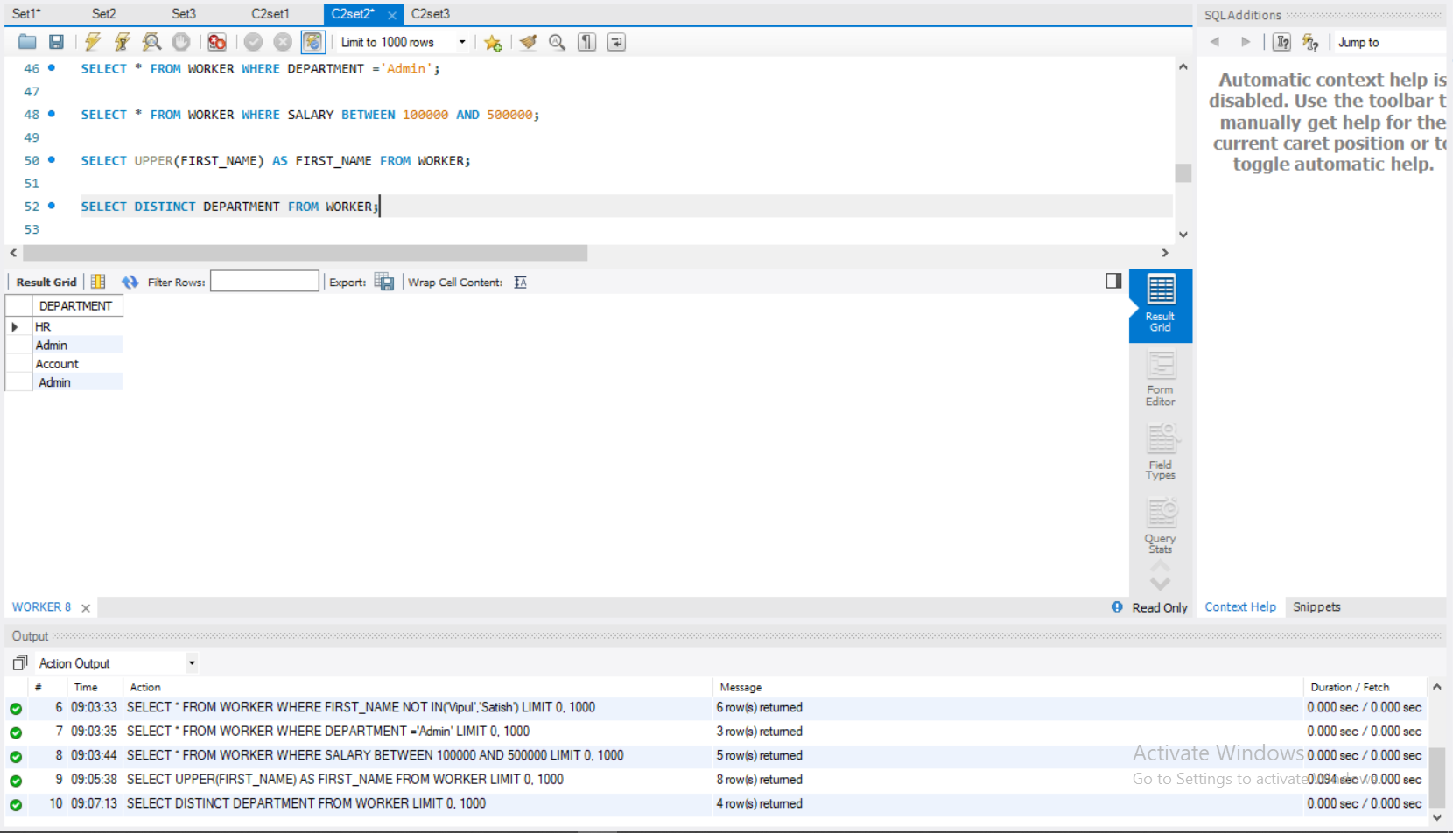

1. **Write An SQL Query To Print First Three Characters Of FIRST_NAME From Worker Table. (Substring ())**

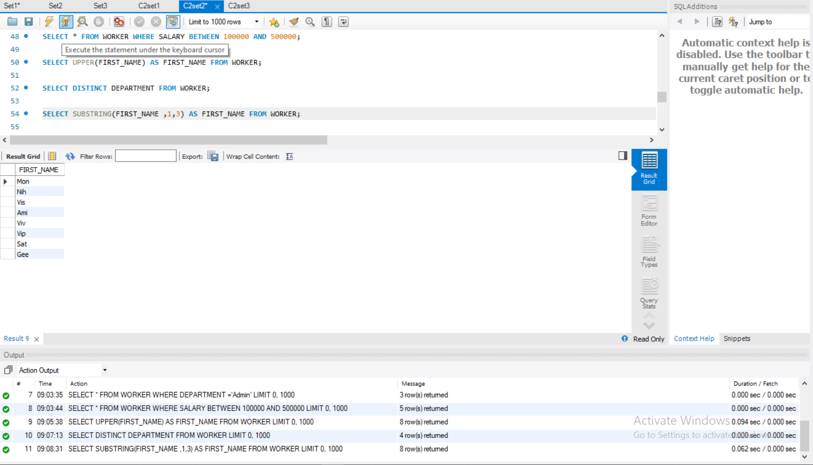

1. **Write An SQL Query To Print The FIRST_NAME From Worker Table After Removing White Spaces From The Right Side( RTRIM ( ))**

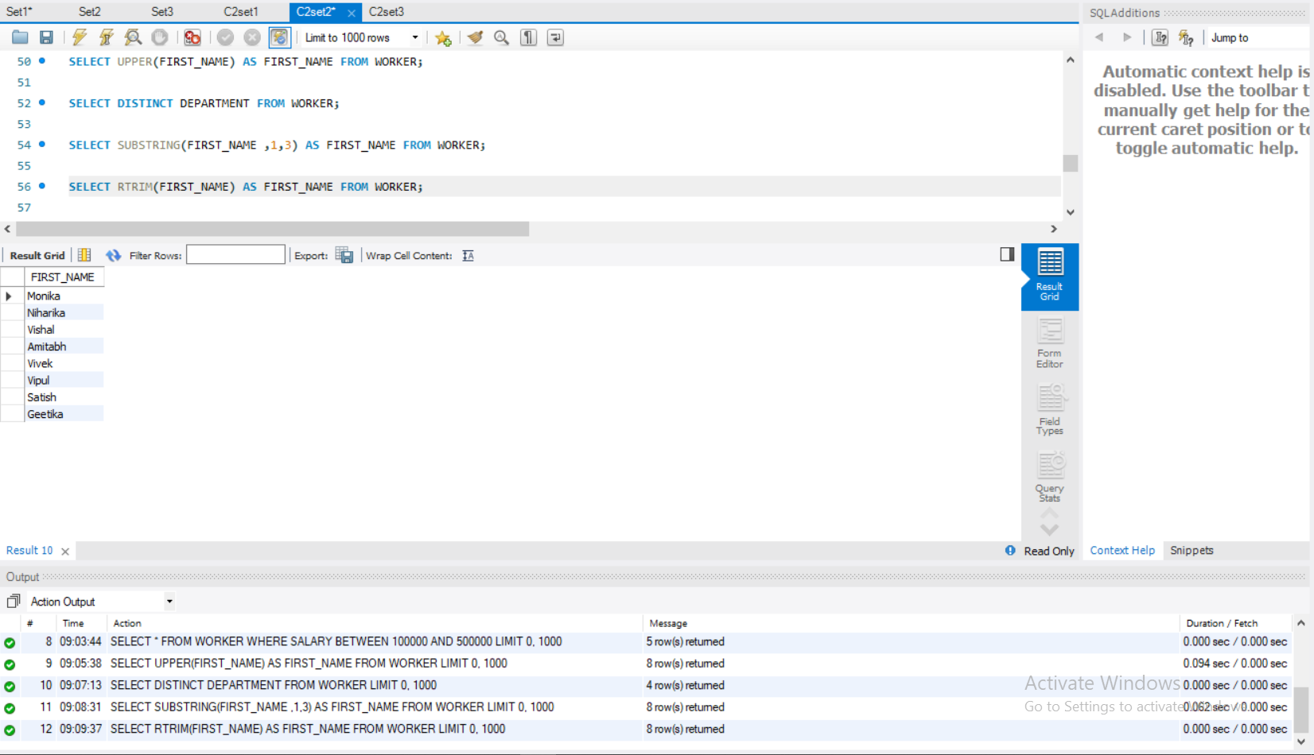

1. **Write An SQL Query To Print The DEPARTMENT From Worker Table After Removing White Spaces From The Left Side. ( LTRIM ( ))**

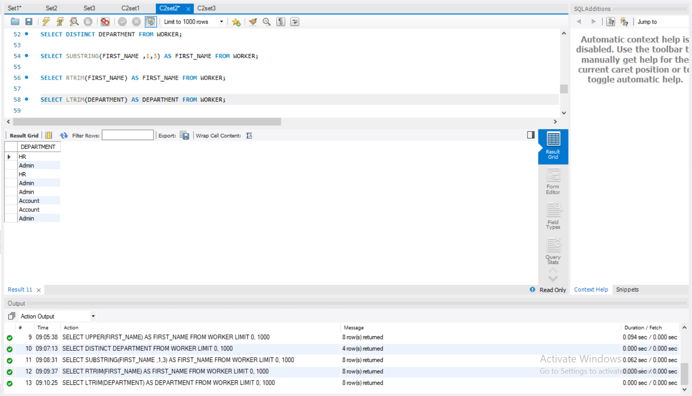

1. **Write An SQL Query That Fetches The Unique Values Of DEPARTMENT From Worker Table And Prints Its Length.( length())**

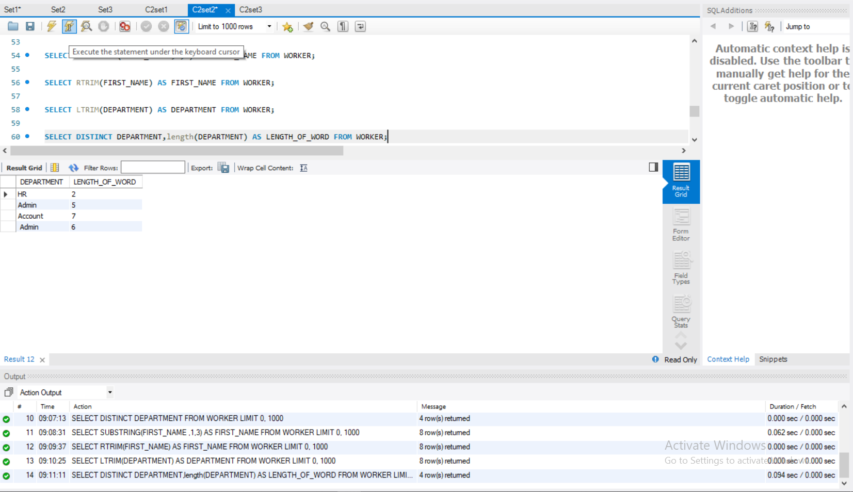

1. **Write An SQL Query To Print The FIRST_NAME From Worker Table After Replacing ‘a’ With ‘A’.( REPLACE( ))**

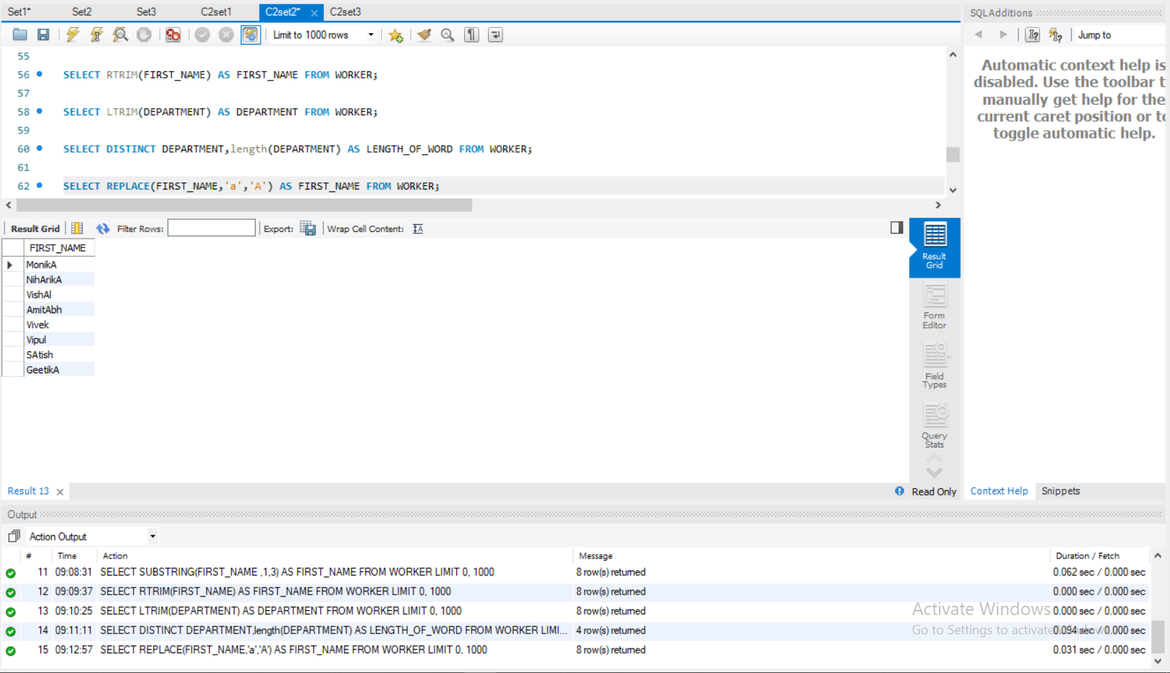

1. **Find the First name , last name ,Department, Salary and Bonus of employees whose bonus amount is greater than 4000**

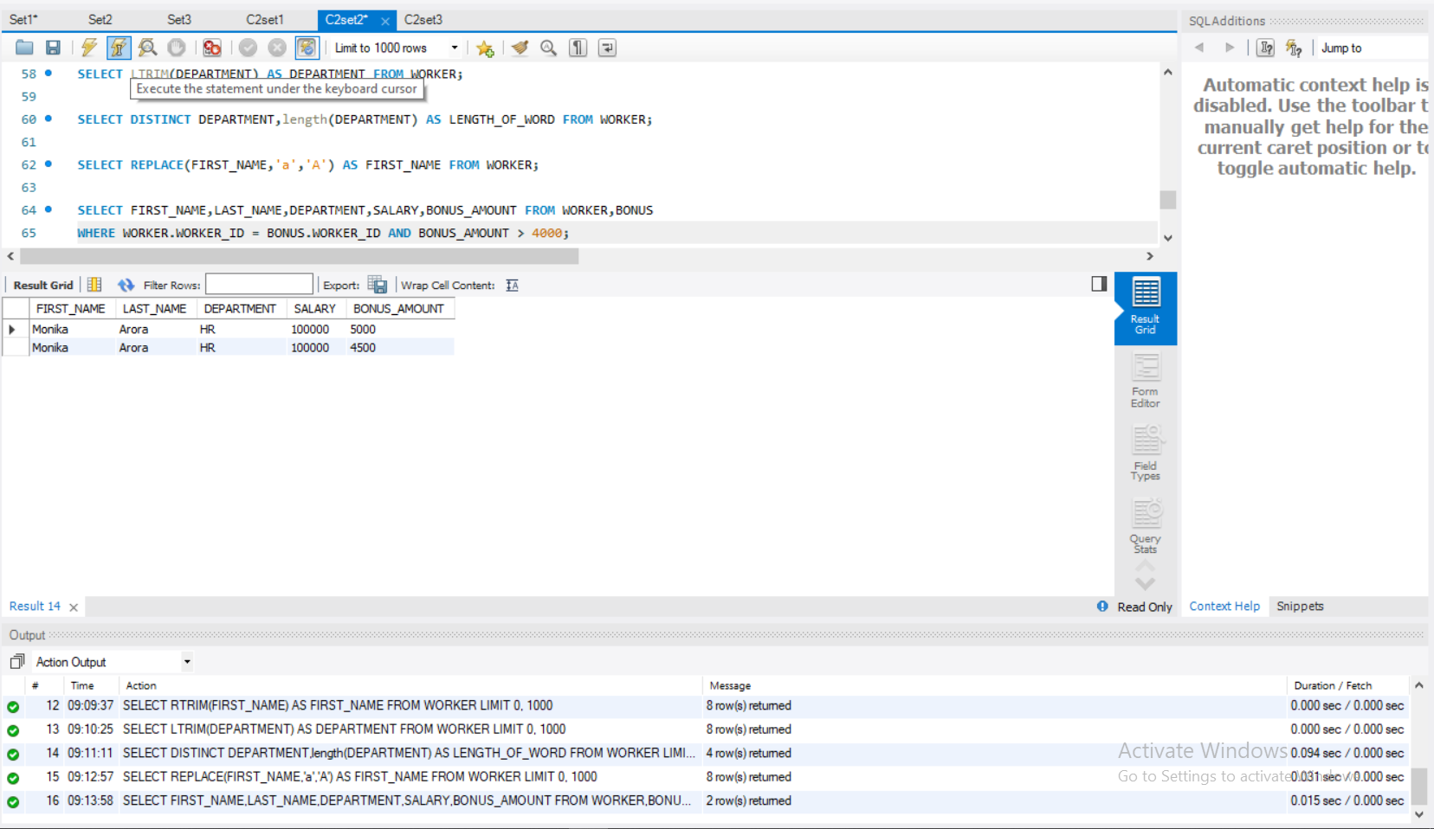

1. **Delete the employee with worker_id=7 from worker and display the details of both tables.**

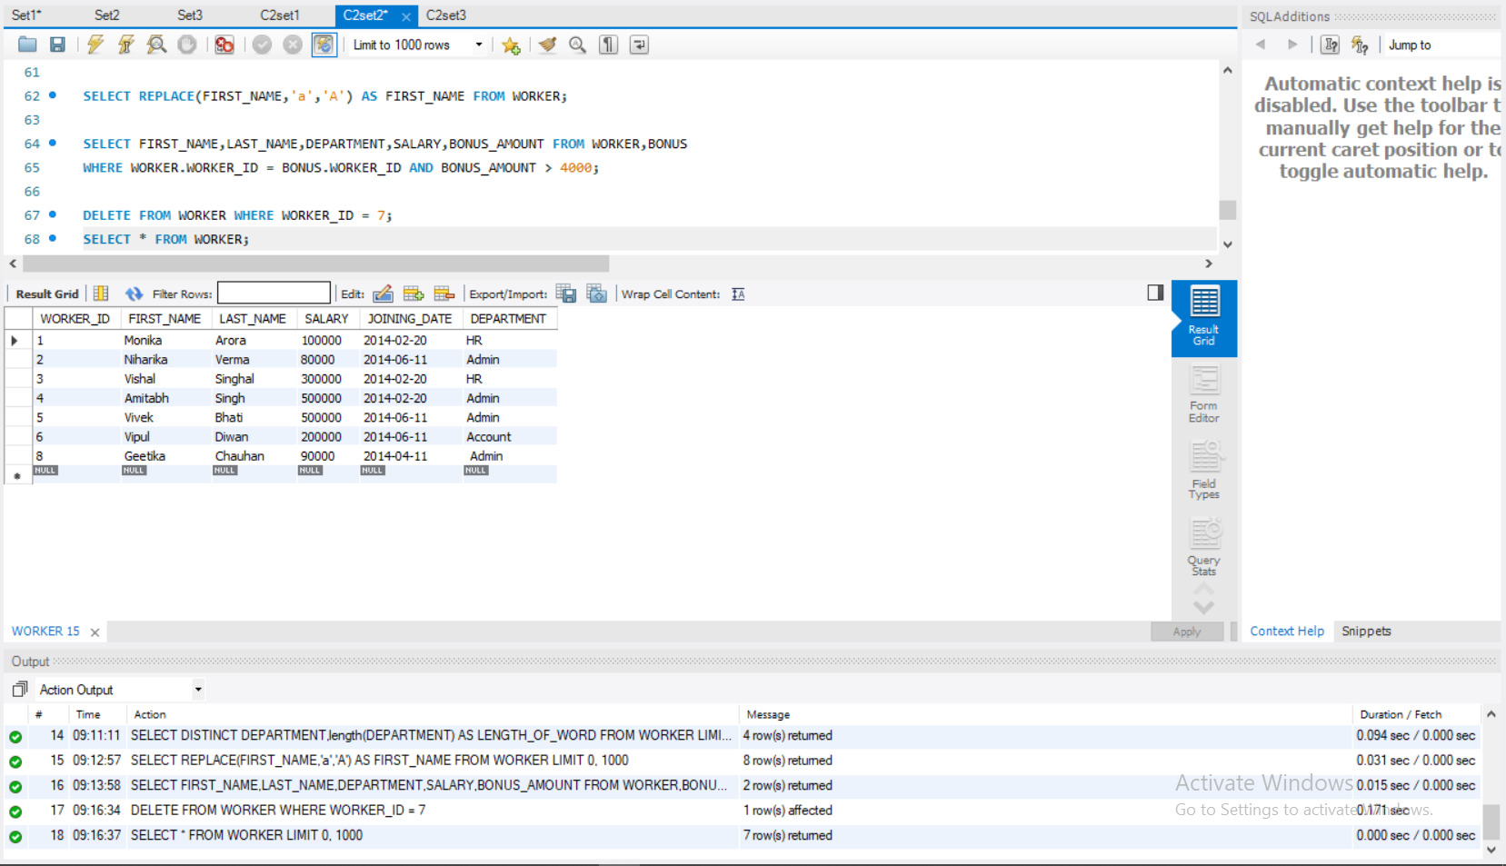

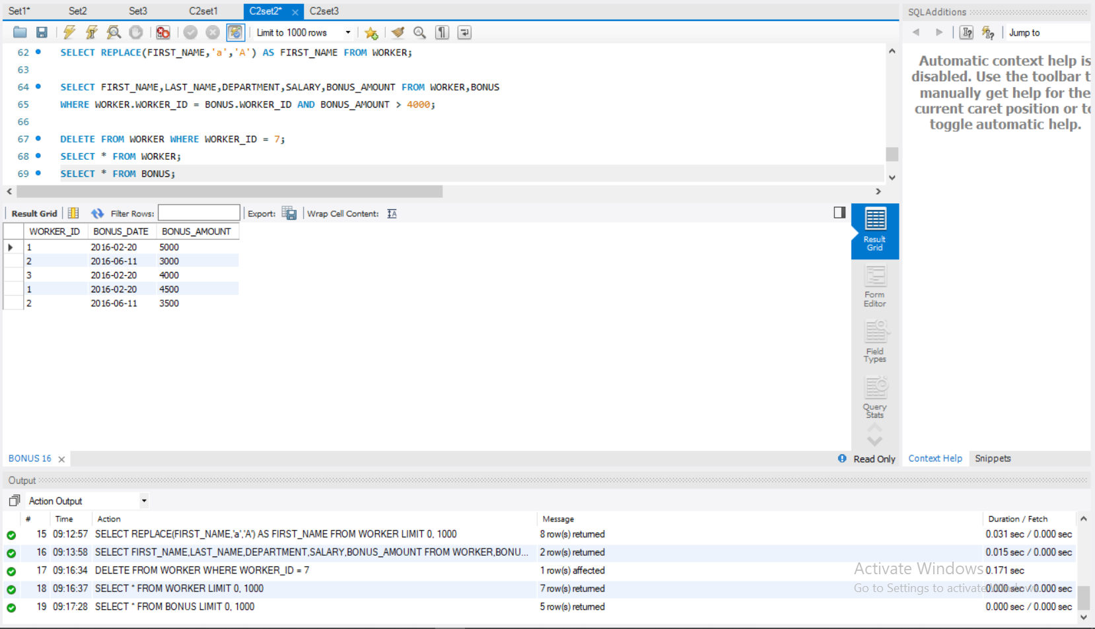

1. **Drop the foreign key constraint and add a new referential integrity constraint with ‘on update or delete with no action’**

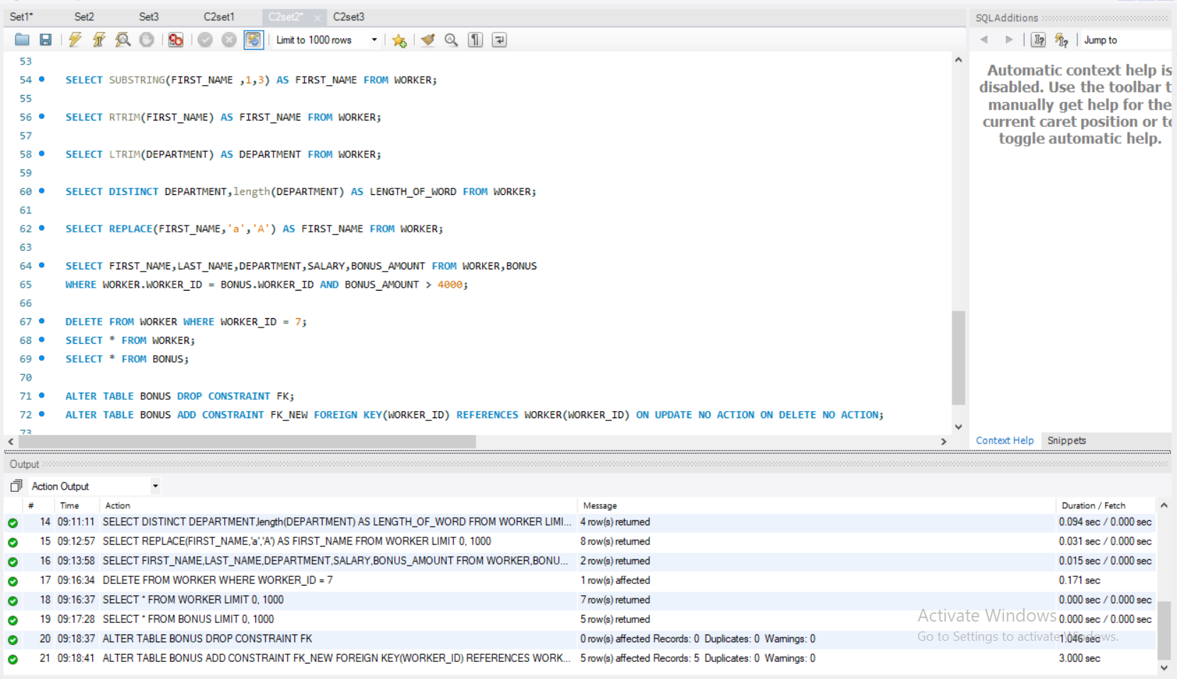

1. **Delete the employee with worker_id = 8 from worker.**

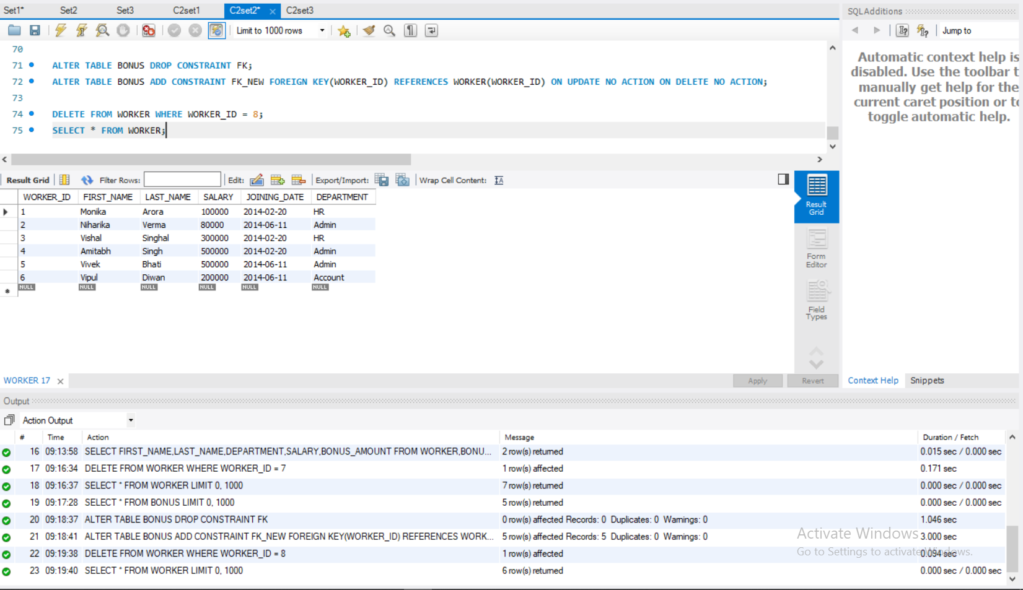

# Q .SET 3

**Create the tables given below and execute the queries:**

## Customer (Cust id: integer, cust_name: string)

## 

## Item(item_id: integer, item_name: string, price: integer)

## 

**Sale (bill_no: integer, bill_date: date, cust_id: integer, item_id: integer, qty_sold: integer)**

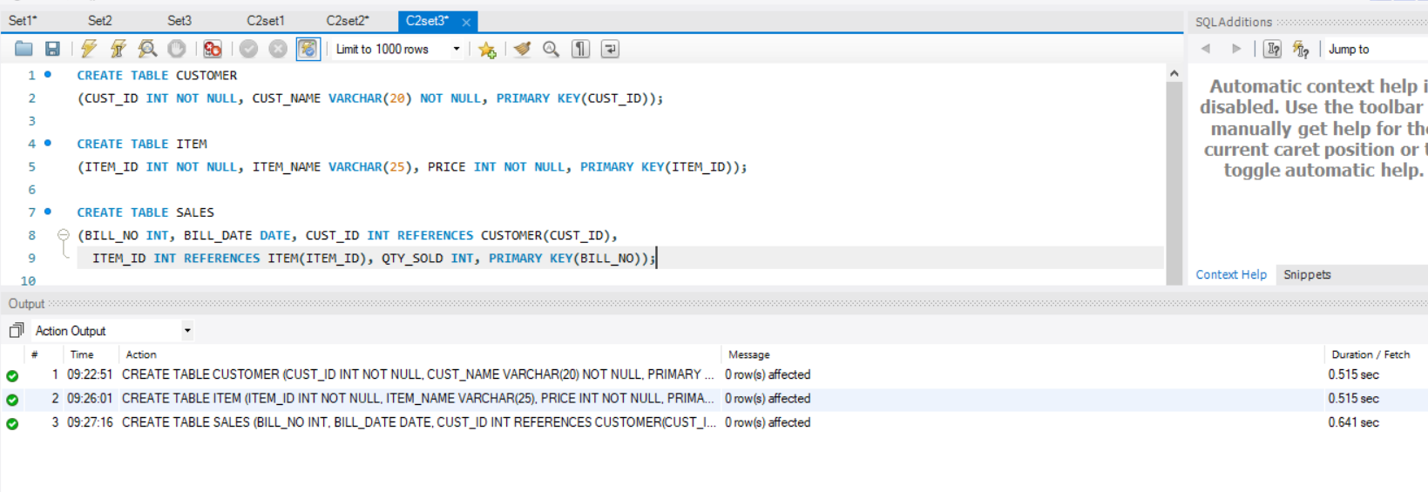

**For the above schema, perform the following—**

1. **Create the tables with the appropriate integrity constraints**
2. **Insert details of 5 customers, 5 items and 10 sales details. There should be one customer ‘rekha’ who had purchased 3 different products on the same date. And there should be atleast one customer who had purchased 2 different products on the same date in the year ‘2018’.**

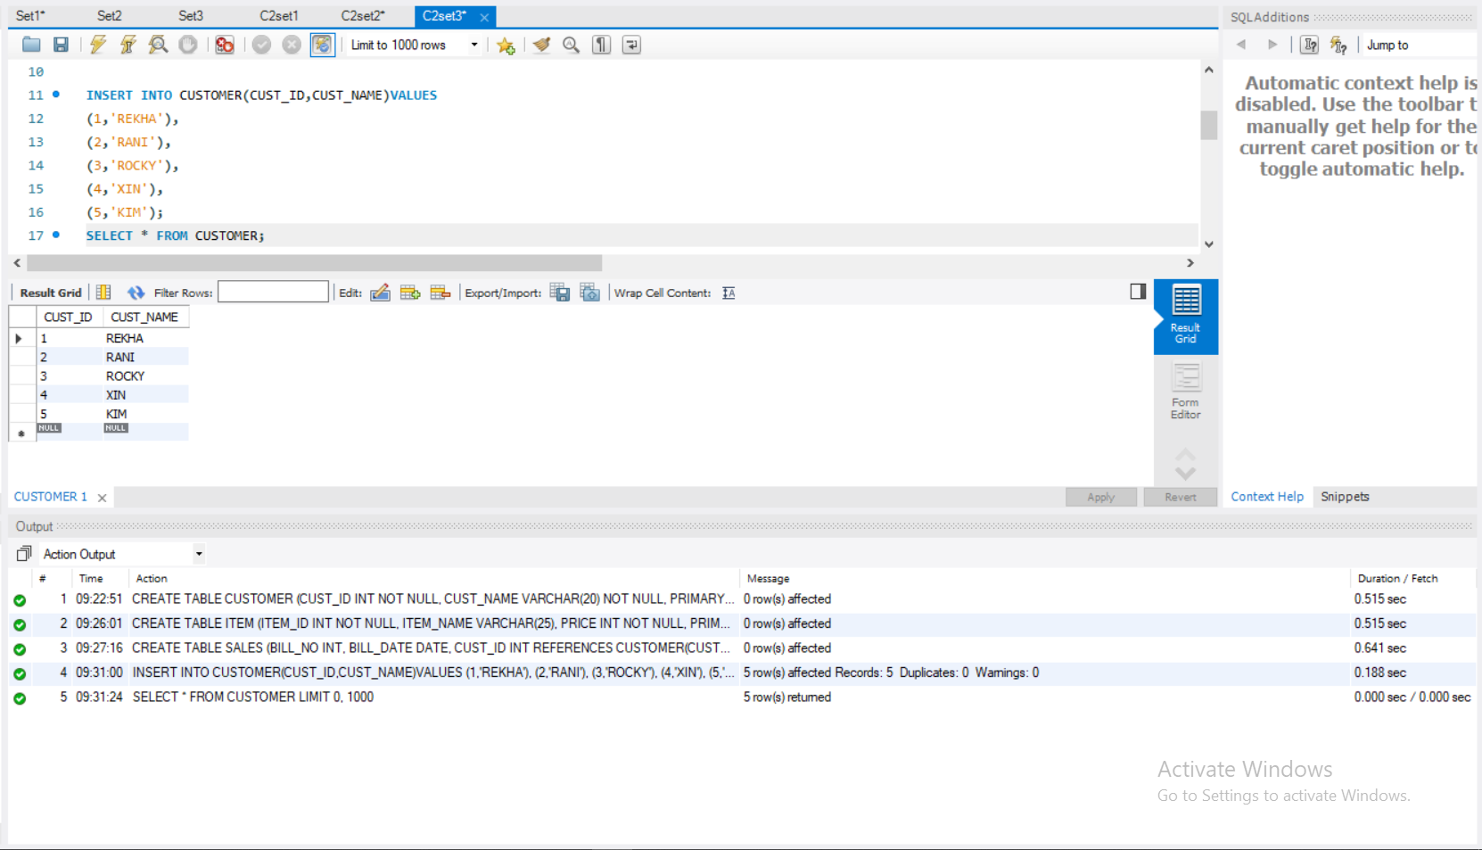

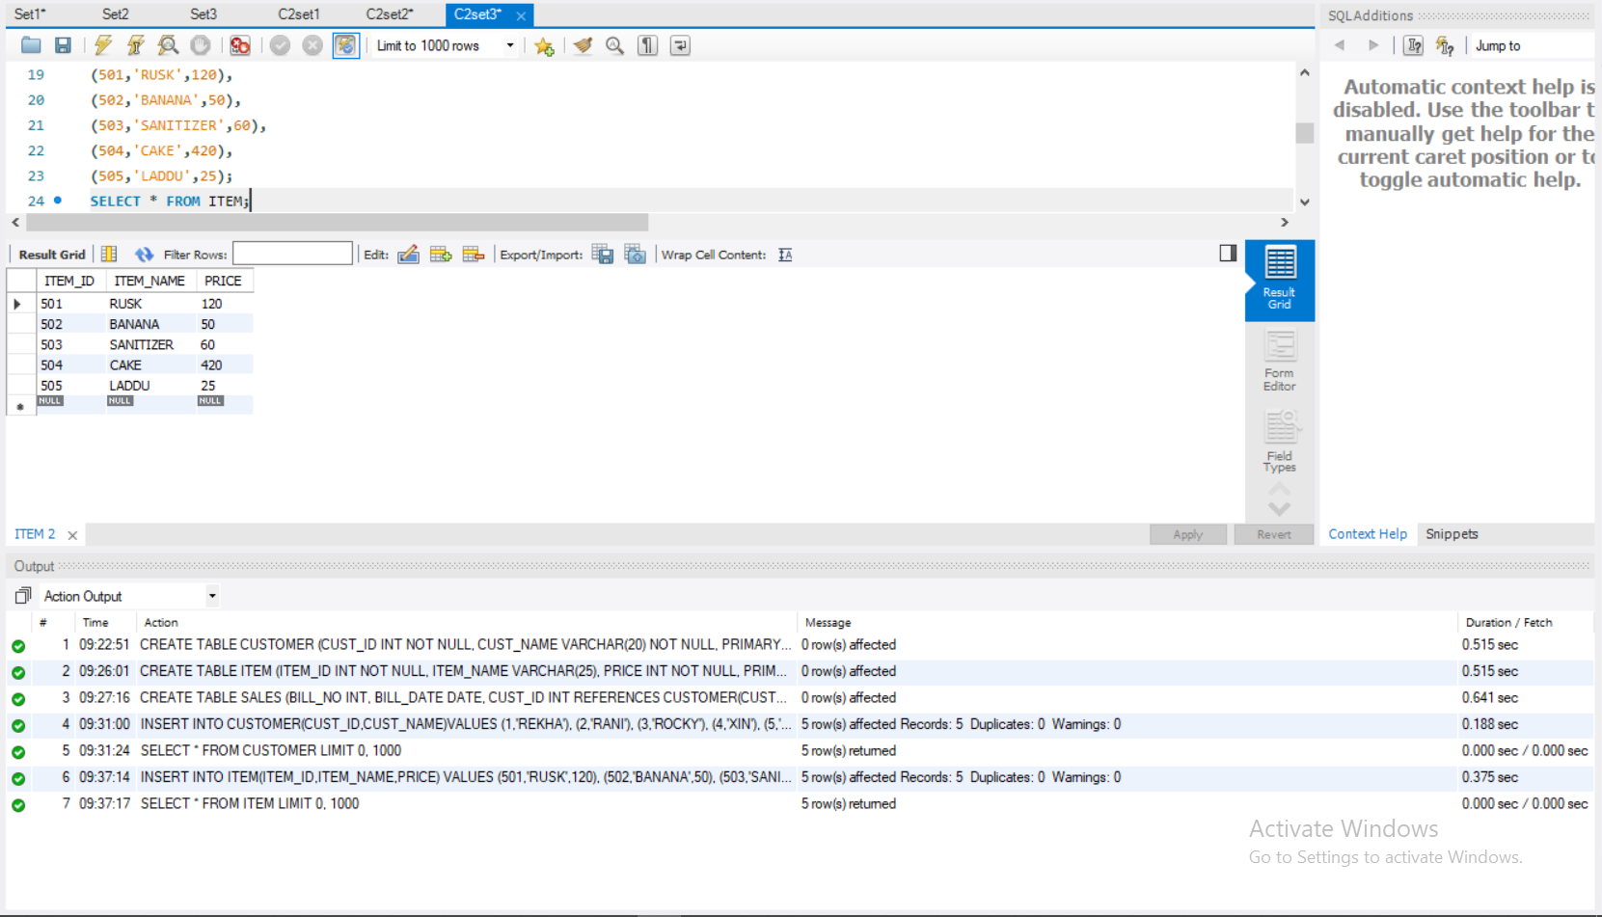

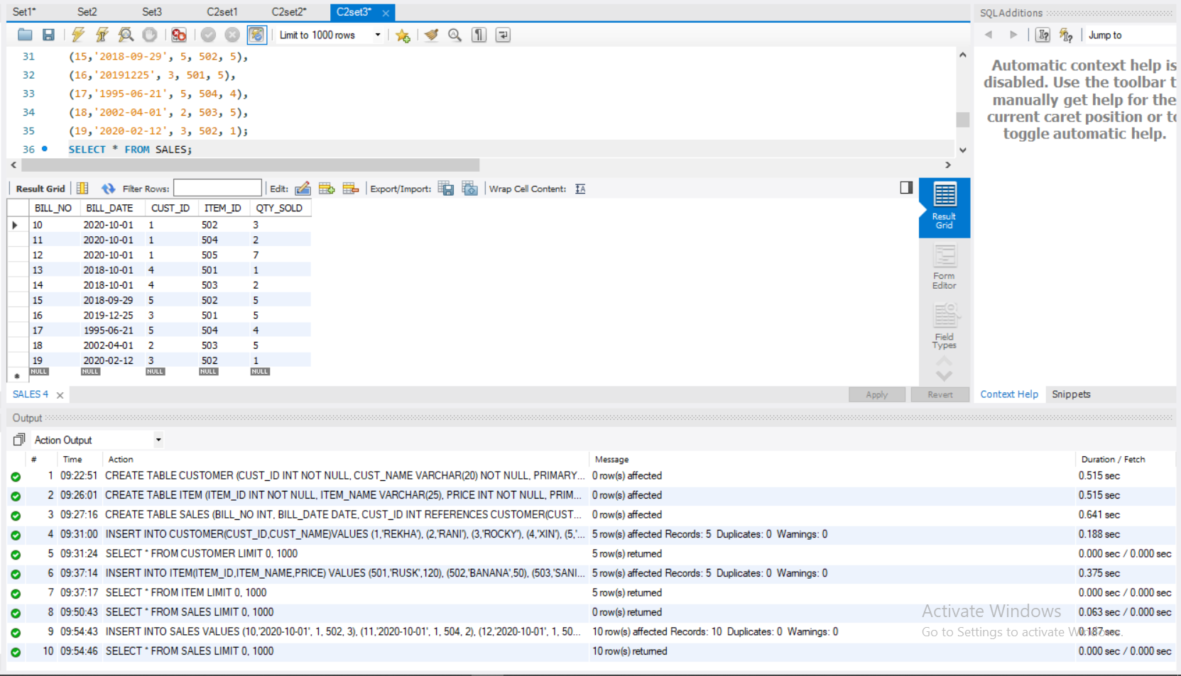

1. **List the details of the customer who have bought a product which has a price>200**

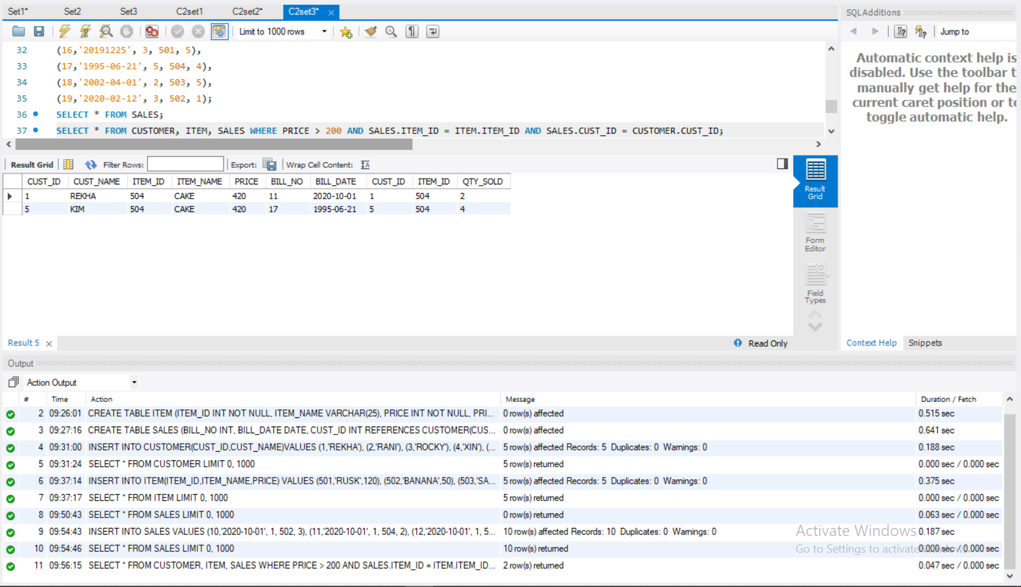

1. **Give a count of how many products have been bought by each customer group by bill date.**

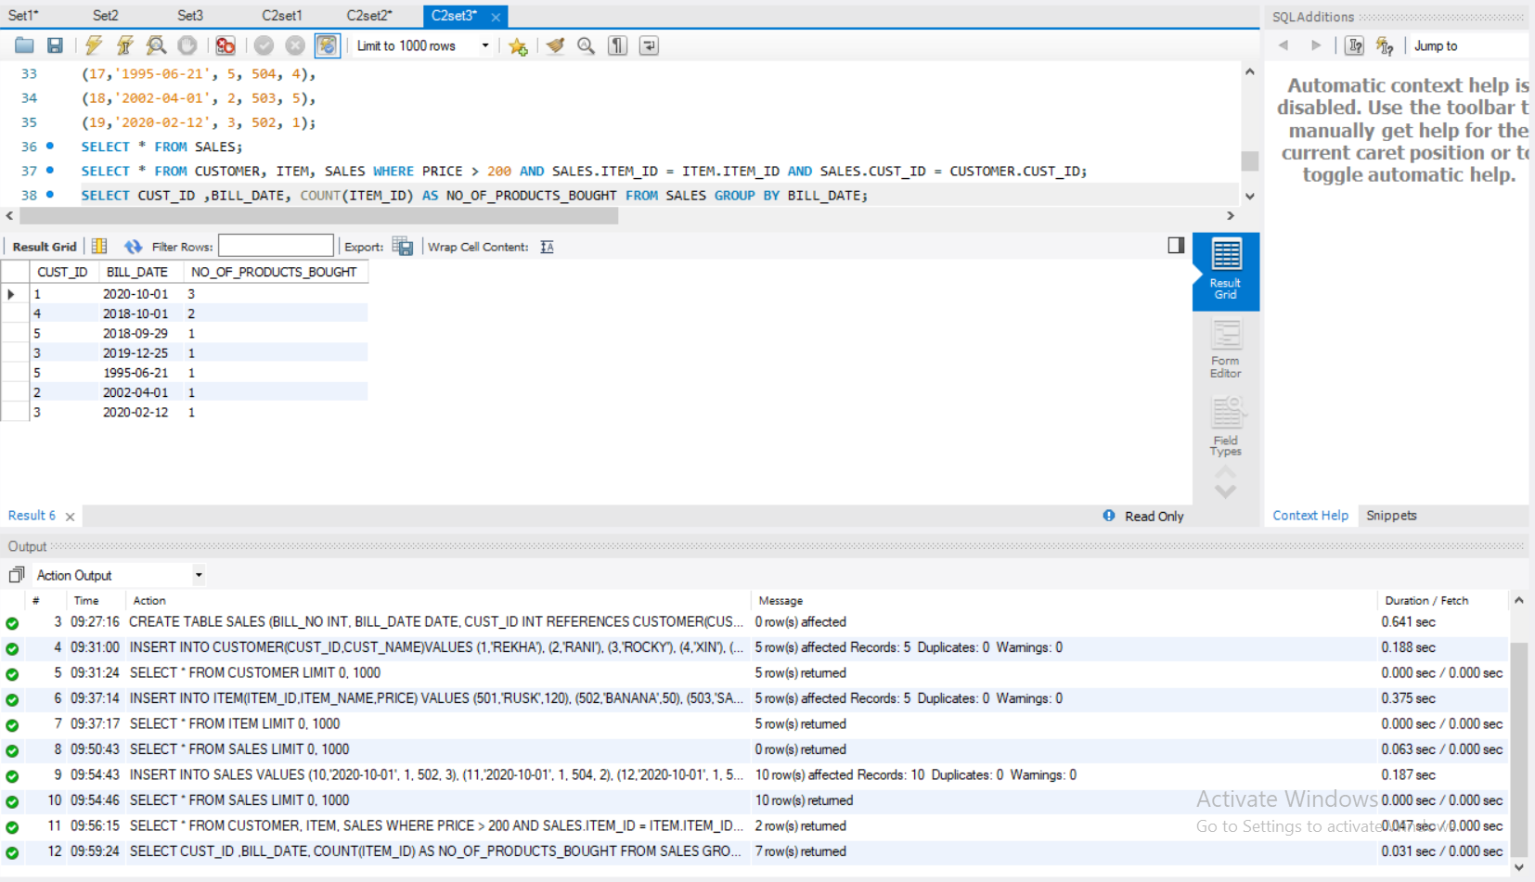

1. **Give a count of how many products have been bought by each customer group by bill date only for the year 2018.**

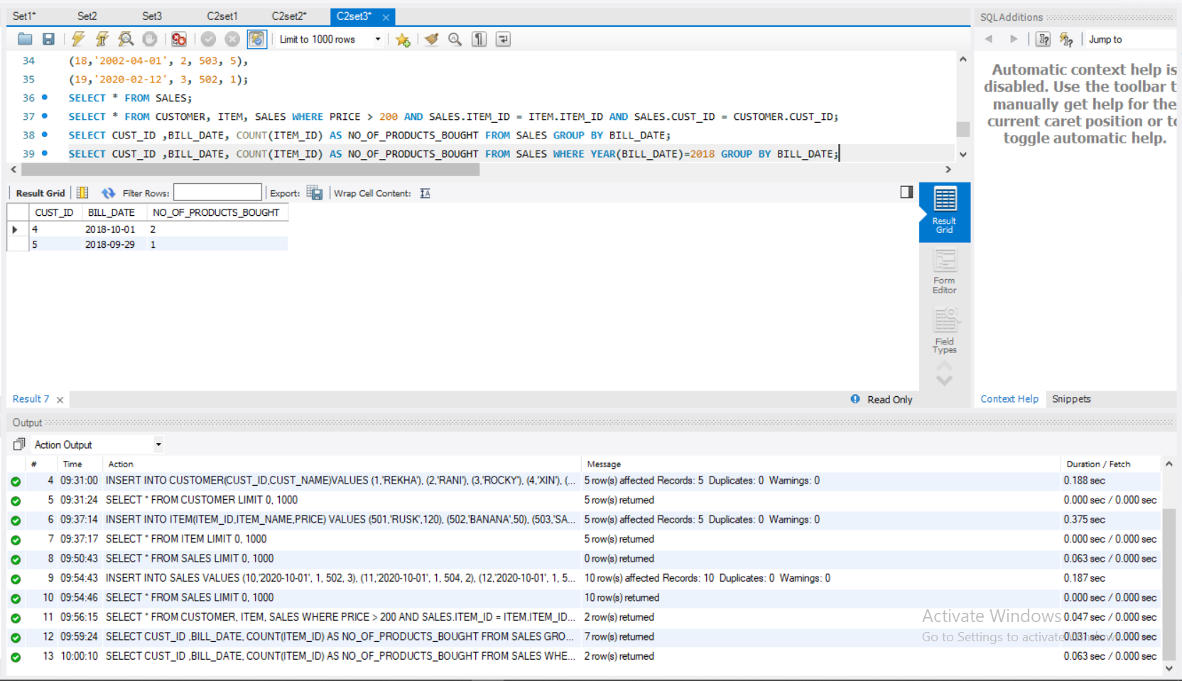

1. **Give a list of products bought by a customer having cust_id as 5**

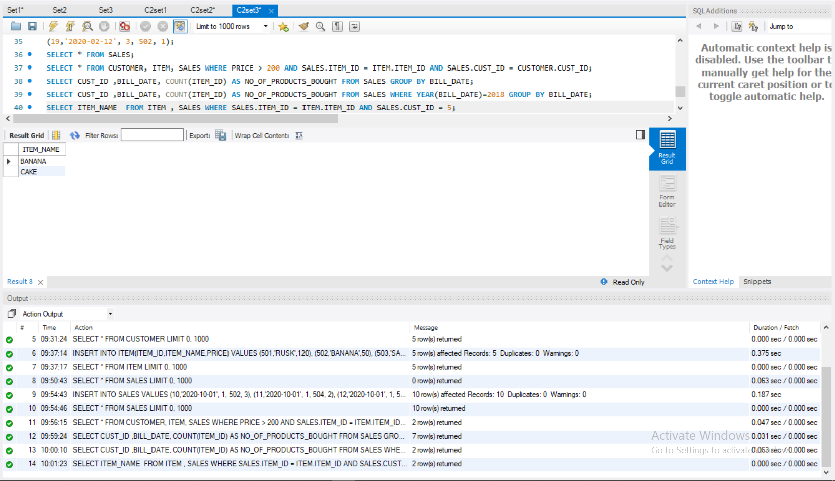

1. **List the item details which are sold as of today**

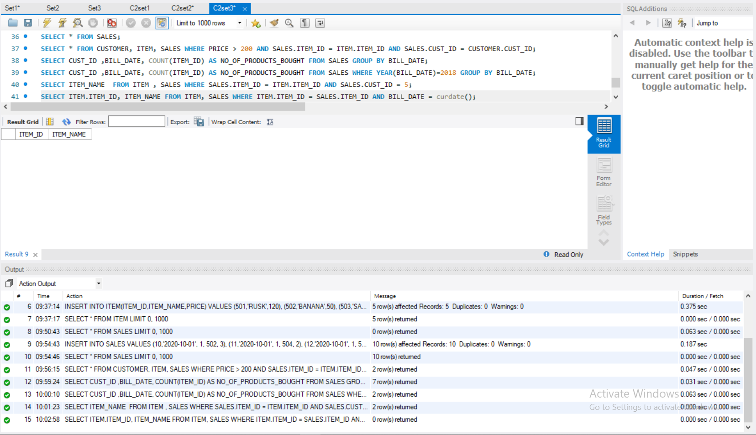

1. **Print the bill in a neat format with the quantity sold, price of the item and the final amount of customer ‘rekha’**

